**Beta Oxidation of Fatty Acids**

**Definition:**

Beta-oxidation is the process by which fatty acid molecules are broken down in the mitochondria to generate acetyl-coA, which enters the citric acid cycle, and NADH and FADH2, which are used by the electron transport chain.

**Transport into the Mitochondrion:**

The b-oxidation pathway is located in the mitochondrion. Short-chain fatty acids are transported through the membrane as free acids followed by their reaction with acetyl-CoA. Another case is long-chain acids that form acetyl-CoA derivatives prior to entry the mitochondrion. In order to transfer them into mitochondrial matrix they must be converted into acylcarnitine derivatives.

Located on the outer side of the inner mitochondrial membrane, carnitine cyltransferase I catalyzes the formation of the O-acylcarnitine. Then translocase transport it across the membrane into matrix where acyltransferase II reforms the fatty acyl-CoA transferring the fatty acyl group back to CoA. Freed carnitine returns across the membrane via the translocase.

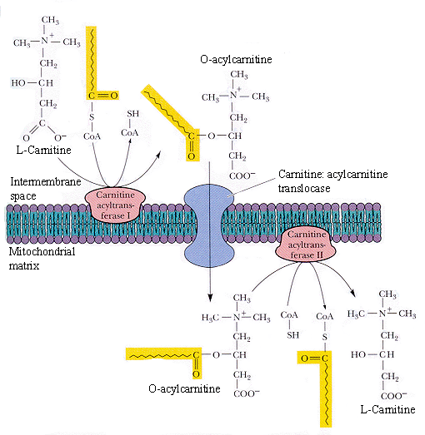

**Steps of Beta Oxidation:**

Beta Oxidation of fatty acids involves 4 steps which are following.

**The First Reaction of Beta Oxidation (Acyl-CoA Dehydrogenase):**

This first reaction is the oxidation of the Ca-Cb bond. It is catalyzed by acyl-CoA dehydrogenases. This catalyst is a family of three soluble matrix enzymes. These enzymes carry noncovalently bound FAD that is reduced during the oxidation of the fatty acid. This is an oxidation reaction and it should be similar to that of the succinate dehydrogenase reaction of the TCA cycle because the first three steps of this pathway are directly analogous to the steps needed to get succinate to oxaloacetate. The *G should therefore be approximately +0.4 kJ/mole.

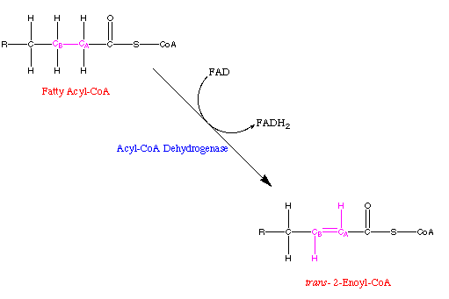

**The Second Reaction of Beta Oxidation (Enoyl-CoA Hydratase):**

The second reaction in this pathway is one in which water is added across the new double bond to make hydroacyl-CoA. The catalyst in this reaction is Enoyl-CoA hydratase. This is also called a crotonase and it converts trans-enoyl-CoA to L-B-Hydroxyacyl-CoA. This reaction would be classified as a hydration reaction because you are adding water. The *G of this reaction should be similar to that of the Fumarase reaction in the TCA cycle, since the first three reactions are directly analogous to the steps to get succinate to oxaloacetate. Therefore, it should be around -3.8 kJ/mole.

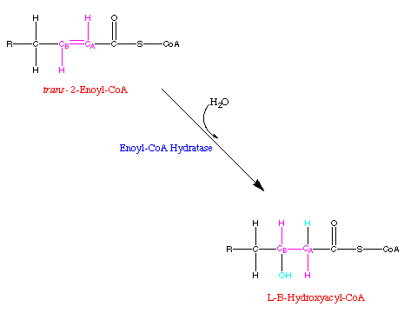

**The Third Reaction in Beta Oxidation (L-Hydroxyacyl-CoA Dehydrogenase):**

The third reaction of this pathway is the oxidation of the hydroxyl group at the beta position which forms a beta-ketoacyl-CoA derivative. This is the second oxidation step in this pathway and it is catalyzed by L-Hydroxyacyl-CoA Dehydrogenase. This enzyme needs to have NAD+ as a coenzyme and the NADH produced represents metabolic energy because for every NADH produced, it drives the synthesis of 2.5 molecules of ATP in the electron transport pathway. So, this reaction is classified as an oxidation reaction and its *G should be similar to that of the Malate Dehydrogenase reaction in the TCA cycle for the same reasons as the ones above. Therefore, it should be approximately +29.7 kJ/mole.

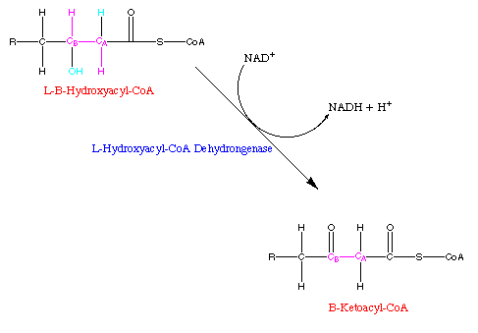

**The Fourth Reaction in Beta Oxidation (Thiolase)**

The fourth and final reaction of this pathway is the thiolase catalyzed reaction. This reaction cleaves the beta-ketoacyl-CoA. The products of this reaction are an acetyl-CoA and a fatty acid that has been shortened by two carbons. So, this reaction is classified as a cleavage reaction and it is actually a reverse Claisen condensation which means that it should have about the same *G as the Isocitrate Dehydrogenase reaction in the TCA cycle. It should be somewhere around -8.4 kJ/mole.

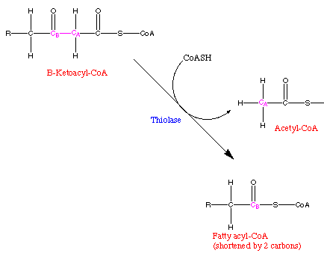

**Repetition of the Beta Oxidation Cycle:**

The shortened fatty acyl-CoA that was the product of the last reaction now goes through another beta oxidation cycle. This keeps happening until eventually you wind up with two molecules of acetyl-CoA in the final step. This acetyl-CoA is then available to be further metabolized in the TCA cycle, or it can be used as a substrate in amino acid biosynthesis. It cannot be used as a substrate for gluconeogenesis.

**Beta Oxidation Cycle:**

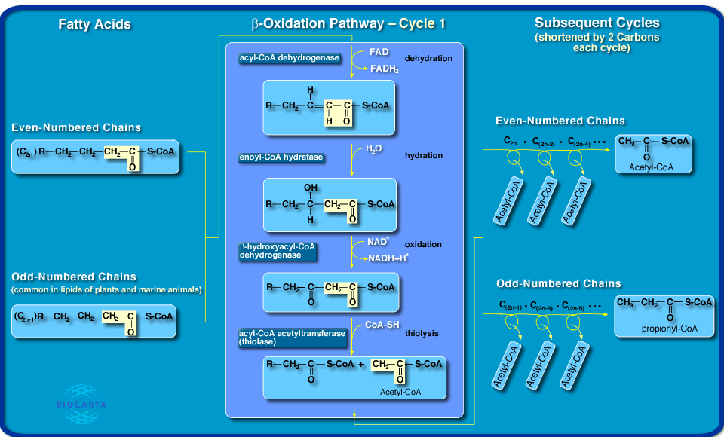

**All Steps of Beta Oxidation:**

