**Carbohydrates**

**An energy source for all kind of life**

An organic compound consisting of **Carbon**, hydrogen and oxygen, those combine together in ratio of 1:2:1 to start synthesis of carbohydrates. **Carbohydrates** are polyhydroxy aldehydes and ketones or substances that hydrolyze to yield polyhydroxy aldehydes and ketones. Aldehydes (–CHO) and ketones (= CO) constitute the major groups in carbohydrates.

Mostly monosaccharide is divided on the basis of number of carbon atoms that contains for example, Triose (3 ) , Tetrose  (4),  Pentose (5),  Hexose  (6) and Heptose  (7), etc.,

**Trioses C3 (C3 H6 O3)**

A triose is a monosaccharide ‘simple sugar containing only three carbon atom’. Examples of trioses are [L-Glyceraldehyde](http://en.wikipedia.org/wiki/Glyceraldehyde) and [D-Glyceraldehyde](http://en.wikipedia.org/wiki/Glyceraldehyde), ([aldoses](http://en.wikipedia.org/wiki/Aldose) ) and [dihydroxyacetone](http://en.wikipedia.org/wiki/Dihydroxyacetone), ([ketose](http://en.wikipedia.org/wiki/Ketone)s). Structures are some common trioses are given here

**Structure**

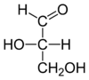 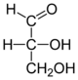

**L (+) glyceraldehyde** **D(+)-glyceraldehyde**

**Aldoses; The**[**carbonyl**](http://en.wikipedia.org/wiki/Carbonyl)**group is at the end of the chain**

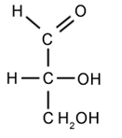 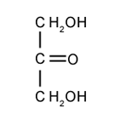

D-Glyceraldehyde Dihydroxyacetone

**Ketoses carbonyl group is in the middle of the chain**

**Tetrose C4 (C**4 **H8 O4)**

Tetroses sugars are [monosaccharide](http://en.wikipedia.org/wiki/Monosaccharide) with 4 [carbon](http://en.wikipedia.org/wiki/Carbon) atoms. They have either an [aldehyde](http://en.wikipedia.org/wiki/Aldehyde) [functional group](http://en.wikipedia.org/wiki/Functional_group) in position 1 (aldotetroses) or a [ketone](http://en.wikipedia.org/wiki/Ketone) functional group in position 2 (ketotetroses).

**Structure**

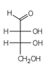 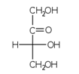

D-Erythrose D-Erythrulose

**Pentoses** C5 (C5 H10 O5) Sugar molecules that contain five carbon atoms are termed pentoses. Pentoses occur in food in very small amounts, although they are an essential part of the genetic material of every cell. The pentoses are divided into two groups Aldopentoses and Ketopentoses.

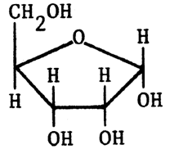 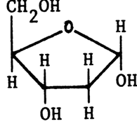

α-D-ribose α-D-deoxyribose

|  |  |
| --- | --- |
|  |  |

**Hexoses** C6 ( C6 H12 O6); A **hexose** is a [monosaccharide](http://en.wikipedia.org/wiki/Monosaccharide) with six [carbon](http://en.wikipedia.org/wiki/Carbon) atoms, having the [chemical formula](http://en.wikipedia.org/wiki/Chemical_formula) C6H12O6. Hexoses are classified by [functional group](http://en.wikipedia.org/wiki/Functional_group), with aldohexoseshaving an [aldehyde](http://en.wikipedia.org/wiki/Aldehyde) at position 1, and [ketohexoses](http://en.wikipedia.org/wiki/Ketohexose) having a [ketone](http://en.wikipedia.org/wiki/Ketone) at position 2

Within the structural formulae D , represents the configuration or direction of the hydroxyl group (OH) on the carbon atom next to the last carbon from the functional or aldehyde group. For example, in the case of D(+)-glyceraldehyde and D(+)-glucose the hydroxyl group on the penultimate carbon atom (ie. C2 and C5 respectively) is on the right side when the aldehyde group (CHO) is at the top of the formula.

The symbol (+) or (-) denotes the direction of optical rotation observed when a solution of that sugar is placed in a polarimeter; dextro-rotatory (clockwise direction, +) or laevorotatory (anti-clockwise direction, -). Virtually all naturally occurring monosaccharides are members of the D series of sugars, the configuration around the penultimate carbon atom being the same as that in D-glyceraldehyde. In addition, all naturally occurring monosaccharides are dextro-rotatory, with the exception of fructose and erythrose.

## Glucose (C6 H12 O6)

Glucose, also known as dextrose, is the most common carbohydrate in nature. Glucose is a basic unit of more complex sugars, or polysaccharides, and is a mildly sweet sugar. In nature, glucose rarely exists as a single molecule. In fact, every disaccharide has glucose as one of its two sugar molecules. Glucose is also part of starch and fiber molecules. Glucose supplies energy to your cells and is the preferred fuel for your brain. Your liver stores and releases glucose when needed to regulate blood sugar levels. Glucose is the sugar tested for by diabetics when they measure blood sugar levels.

There is considerable evidence to suggest that monosaccharides may also exist in a ring or cyclic molecular form. For example, two cyclic forms of D-glucose are known to occur in nature; α-D-glucose and β-D-glucose. As with the chain formulae, the difference between these two cyclic forms depends upon the configuration or direction of the hydroxyl group on carbon atom 1.

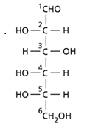 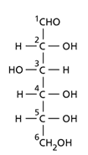

L- Glucose D-Glucose

The configuration at the anomeric centre (that derived from the carbonyl carbon) is denoted alpha- (α-) or beta- (β-) by reference to the stereocentre that determines the absolute configuration. In a Fischer projection, if the substituent off the anomeric centre is on the same side as the oxygen of the configurational (D- or L-) carbon then it is the α--anomer. If it is directed in the opposite direction it is the β-anomer ( Haworth structure for sugar molecules)

|  |  |
| --- | --- |
|  |  |
| http://www.fao.org/docrep/field/003/ab470e/AB470E31.gif | http://www.fao.org/docrep/field/003/ab470e/AB470E32.gif |
| α-D-glucose | β-D-glucose |

The structural configuration determining the physical and biological properties of polysaccharides composed of individual monosaccharide units. For example, the polysaccharide cellulose is composed of insoluble chains of β-glucose units, whereas the polysaccharides starch and glycogen are composed of more biological reactive helical or branched chains of α-glucose units.

## Fructose (C6H12O6) Fructose: like glucose, fructose is found in its free state in plant juices, fruit and honey. It is a component of the disaccharide sucrose, and is the sweetest sugar known in nature (ie. it is responsible for the exceptional sweet taste of honey).

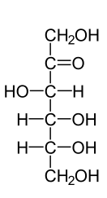 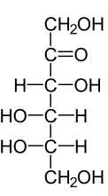

**D(-) Fructose L (-) Fructose**

**Mutarotation**

The aldehyde and ketone functional groups in the carbohydrates react with adjacent  [hydroxyl](http://en.wikipedia.org/wiki/Hydroxyl) functional groups to form  compounds like  [hemiacetals](http://en.wikipedia.org/wiki/Hemiacetal) and [hemiketals](http://en.wikipedia.org/wiki/Hemiketal). The resulting ring structure is related to [pyran](http://en.wikipedia.org/wiki/Pyran) ( **Pyran** or **oxine** is a six-membered [heterocyclic](http://en.wikipedia.org/wiki/Heterocyclic), non-aromatic ring, consisting of five [carbon](http://en.wikipedia.org/wiki/Carbon) atoms and one [oxygen](http://en.wikipedia.org/wiki/Oxygen) atom and containing two [double bonds](http://en.wikipedia.org/wiki/Double_bond) ) and is termed a [pyranose](http://en.wikipedia.org/wiki/Pyranose) (Pyranose is a collective term for [carbohydrates](http://en.wikipedia.org/wiki/Carbohydrate) that have a chemical structure that includes a six-membered ring consisting of five carbon atoms and one oxygen atom. The ring spontaneously opens and closes, allowing rotation to occur about the bond between the [carbonyl](http://en.wikipedia.org/wiki/Carbonyl) group and the adjacent carbon atom, yielding two distinct configurations (α and β). This process is also termed [mutarotation](http://en.wikipedia.org/wiki/Mutarotation).

**Glycosidic bond**

***Stereoisomerism***

Stereoisomerism is those having same chemical formula but different structural orientation H and OH in space. It has three types:

1. *Epimerism:*in which position of H or OH is changed on any of chiral carbon
2. *Anomerism:* in which position of H or OH changed on annomeric (functional group carbon) carbon atom which is first carbon in case of aldehyde and second in case of ketonic sugar.

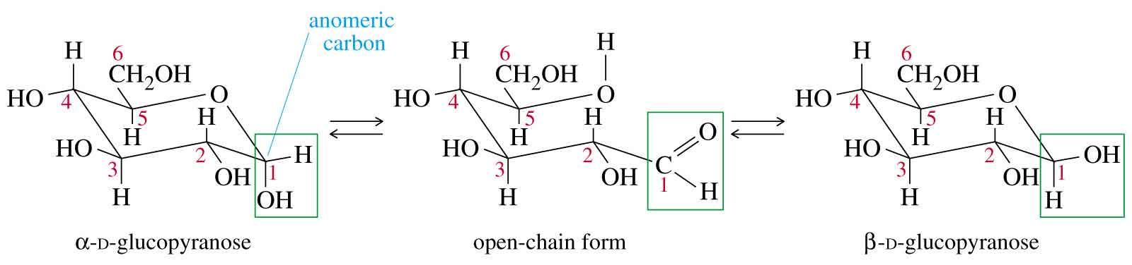

1. *Enantiomerism:*in which dextro form is changed with leavo form, they are the mirror image of each other’s and differs in position of H and OH on penultimate carbon atom.

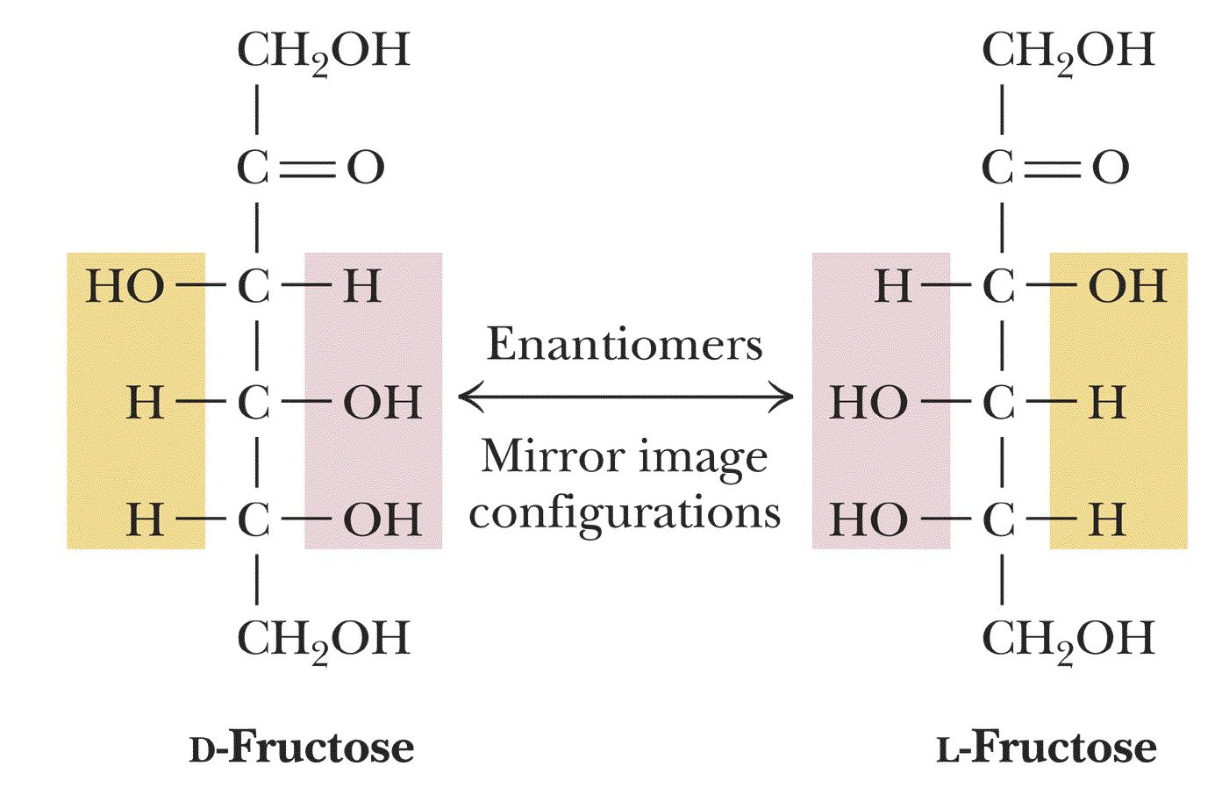

**Disaccharide C12H24O11**

Two monosaccharide joined together by a [glycosidic linkage](http://science.uvu.edu/ochem/index.php/alphabetical/g-h/glycosidic-link/), which  is called a double sugar or disaccharide. The most common disaccharide is sucrose. It is composed of glucose and fructose. Sucrose is commonly used by [plants](http://biology.about.com/od/plantbiology/a/aa100507a.htm) to transport sugar from one part of the plant to another.

## Sucrose ( C12 H22 O11), Molecular weight 360, Molecular mass 324.3 g/mol, Melting point 186 C, Density 1.59 g/cm3, soluble in water .

## Sucrose is the [organic compound](http://en.wikipedia.org/wiki/Organic_compound) commonly known as table sugar . A white, odorless, crystalline powder with a sweet taste, it is best known for its [nutritional](http://en.wikipedia.org/wiki/Nutrition) role. When two monosaccharides molecules ( Glucose and Fructose ) combined together through a glycosdic bond a non reducing sugar molecule of sucrose is formulated . A reducing sugar is any sugar in solution that has an aldehyde or ketone group. Because sucrose is made via the dehydration reaction of the aldehyde group on the glucose molecule and the ketone group on the fructose molecule, no aldehyde or ketone groups are left when sucrose is formed. When aldehydes are present, they can be oxidized, and in the process become reduced. Although ketones cannot be oxidized directly, ketones may convert to aldehydes, which are capable of being reduced.  Sucrose provides quick energy as it is readily digested in the stomach by simple acid hydrolysis.



**Maltose** ( C12H22 O11) Molecular weight 360, Molecular mass 342.3 g/mol, Melting Point 102 C, Density 1.54 g/cm3, soluble in water .

 Maltose is the disaccharide produced when [amylase](http://en.wikipedia.org/wiki/Amylase) breaks down [starch](http://en.wikipedia.org/wiki/Starch). It is found in germinating seeds such as [barley](http://en.wikipedia.org/wiki/Barley) as they break down their starch stores to use for food. It is also produced when glucose is [caramelized](http://en.wikipedia.org/wiki/Caramelization). Maltose consist of two units of glucose joined  with an α(1→4) [bond](http://en.wikipedia.org/wiki/Glycosidic_bond), formed from a [condensation reaction](http://en.wikipedia.org/wiki/Condensation_reaction). Maltose is  also known as maltobiose or malt sugar The [isomer](http://en.wikipedia.org/wiki/Isomer) [isomaltose](http://en.wikipedia.org/wiki/Isomaltose) has two glucose molecules linked through an α(1→6) bond. Maltose is reducing sugar and show mutarotation

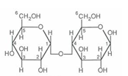Maltose

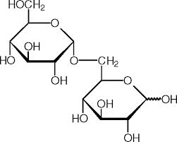  
Isomaltose

**Lactose** ( C12 H22 O11) Molecular Weight 360 ,Molecular mass 342.3 g/mol, melting point 202.8 C, soluble in water and ethanol .

Lactose is a [disaccharide](http://en.wikipedia.org/wiki/Disaccharide) [sugar](http://en.wikipedia.org/wiki/Sugar) derived from [galactose](http://en.wikipedia.org/wiki/Galactose) and [glucose](http://en.wikipedia.org/wiki/Glucose) that is found most notably in cow [milk](http://en.wikipedia.org/wiki/Milk). Lactose makes up around 2~8% of milk (by weight), although the amount varies among species and individuals. It is extracted from sweet or sour [whey](http://en.wikipedia.org/wiki/Whey). The name comes from *lac* or *lactis*, the [Latin](http://en.wikipedia.org/wiki/Latin) word for milk, plus the -ose ending used to name sugars. It has a formula of C12H22O11. In most glucose and galactose are linked with each other by B 1-4 bond

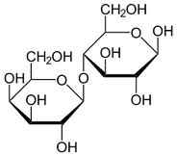

**Lactose**

**Oligosaccharides**these are the carbohydrates which gives 3-10 monosaccharides units on hydrolysis.

**Trisaccharide** Trisaccharides, which yield three monosaccharide molecules on hydrolysis. Example     is raffinose, which has molecular formula, C18H32O16.

# Polysaccharides

Polysaccharides are complex carbohydrates formed from monosaccharides. A number of monosaccharide molecules such as those of glucose, become linked by glycosidic bonds with the elimination of a molecule of water for each monosaccharide added. When a polysaccharide has multiple molecules of the same type, it is described as homopolysaccharide. For example, starch, cellulose and glycogen are composed of only glucose. When a polysaccharide molecule is formed by more than one type of monosaccharide molecules, it is described as a heteropolysaccharide. For example, chitin, heparin, hyaluronic acid and chondroitin sulphate etc.,

**Polysaccharide Branching**

Unbranched polysaccharides contain only α 1,4 linkages. However, there exists branched polysaccharides which are branched by virtue of certain molecules being linked to a molecule via α 1,4 and another via α 1,6 glycosidic bonds. The rate at which these bonds appear may vary. The plant based amylopectin contains a branch every 30 units while the animal based glycogen contains a branch approximately every 10 units. In digesting these branched polysaccharides, α-amylase is the relevant catalyst. α-amylase, however, only digests α-1,4 glycosidic bonds, leaving [disaccharide](http://en.wikibooks.org/wiki/Structural_Biochemistry/Carbohydrates/Disaccharides)/polysaccharide fragments containing α-1,6 bonds and these smaller bonds are known as Dextrins.

**Polysaccharides ( Glycogen and Cellulose)**

**Amylase**

##### different polysaccharides structures

The biologically important polysaccharides and their functions.

| **Polysaccharide** | **Composition** | **Occurrence** | **Functions** |
| --- | --- | --- | --- |
| 1. Starch | Polymer of glucose containing a straight chain of glucose molecules (amylose) and a branched chain of glucose molecules (emylopectin) | In several plant species as main storage carbohydrate | Storage of reserve food |
| 2. Glycogen | Polymer of glucose | Animals (equivalent of starch) | Storage of reserve food |
| 3. Insulin | Polymer of fructose | In roots and tubers (like Dahlia) | Storage of reserve food |
| 4. Cellulose | Polymer of glucose | Plant cell wall (most abundant organic molecule on the_Earth) | Cellwall matrix |
| 5. Pectin | Polymer of galactose and its derivatives | Plant cellwall | Cellwall matrix |
| 6. Hemicellulose | Polymer of pentoses and sugar acids | Plant cellwall | Cellwall matrix |
| 7. lignin | Polymer of glucose | Plant cellwall (dead cells like sclerenchyma) | Cellwall matrix |
| 8. Chitin | Polymer of glucose | Bodywall of arthropods. In some fungi also | Exoskeleton Impermeable to water |
| 9. Hyaluronic acid | Polymer of sugar acids | Connective tissue matrix. Outer coat of mammalian eggs | Ground substance, protection |
| 10. Chondroitin sulphate | Polymer of sugar acids | Connective tissue matrix | Ground substance |
| 11. Heparin | Closely related to chondroitin | Connective tissue cells | Anticoagulant |
| 12. Gums and mucilages | Polymers of sugars and sugar acids | Gums - barks of trees. Mucilages-flower | Retain water in dry seasons |

**Use of Polysaccharides**

## Polysaccharides have several roles. Polysaccharides such as starch, glycogen, and dextrans are all stored in the liver and muscles to be converted to energy for later use. Amylose and Amylopectin are polysaccharides of starch. Amylose has a linear chain structure made up of hundreds of glucose molecules that is linked by a alpha 1,4 glycosidic linkage. Due to the nature of these alpha 1,4 bonds, the macromolecule often assumes a bent shape. The starch molecules form a hollow helix that is suitable for easy energy access and storage. This gives starch a less fibrous quality and a more granule-like shape which is better suited for storage. Unlike the linear structure of Amylose, the Amylopectin starches are branched containing an alpha 1,6 glycosidic linkage about every 30 glucose units. Like amylose it is a homopolymer composed of many glucose units. Glycogen is found in animals, and it is branched like amylose. It is formed by mostly alpha 1,4 glycosidic linkages but branching occurs more frequently than in amylose as alpha 1,6 glycosidic linkages occur about every ten units. Other polysaccharides have structural functions. For example, cellulose is a major component in the structure of plants. Cellulose is made of repeating beta 1, 4-glycosidic bonds. These beta 1,4-glycosidic bonds, unlike the alpha 1,4 glycosidic bonds, force celullose to form long and sturdy straight chains that can interact with one another through hydrogen bonds to form fibers.

## Cellulose

Cellulose is an [organic compound](http://en.wikipedia.org/wiki/Organic_compound) with the [formula](http://en.wikipedia.org/wiki/Chemical_formula) ([C](http://en.wikipedia.org/wiki/Carbon)6[H](http://en.wikipedia.org/wiki/Hydrogen)10[O](http://en.wikipedia.org/wiki/Oxygen)5)n, a [polysaccharide](http://en.wikipedia.org/wiki/Polysaccharide) consisting of a linear chain of several hundred to over ten thousand [β(1→4) linked](http://en.wikipedia.org/wiki/Glycosidic_bond) [D-glucose](http://en.wikipedia.org/wiki/Glucose) units

**Starch** consists of two fractions. About 20% is a water soluble material called amylose. Molecules of amylose are linear chains of several thousand glucose units joined by alpha C-1 to C-4 glycoside bonds. Amylose solutions are actually dispersions of hydrated helical micelles. The majority of the starch is a much higher molecular weight substance, consisting of nearly a million glucose units, and called amylopectin. Molecules of amylopectin are branched networks built from C-1 to C-4 and C-1 to C-6 glycoside links, and are essentially water insoluble ( ).

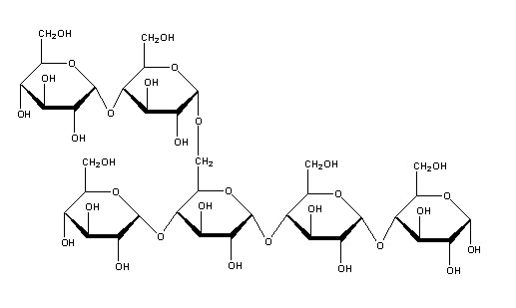

**Structure of starch molecule**

Hydrolysis of starch, usually by enzymatic reactions, produces a syrupy liquid consisting largely of glucose. When corn starch is the feedstock, this product is known as corn syrup. It is widely used to soften texture, add volume, prohibit crystallization and enhance the flavor of foods.  
Glycogen is the glucose storage polymer used by animals. It has a structure similar to amylopectin, but is even more highly branched (about every tenth glucose unit). The degree of branching in these polysaccharides may be measured by enzymatic or chemical analysis.

**Glycogen**

Many organisms store energy in the form of polysaccharides, commonly homopolymers of glucose. Glycogen, the sugar used by animals to store energy, is composed of alpha-1, 4-glycosidic bonds with branched alpha-1, 6 bonds present at about every tenth monomer. Starch, used by plant cells, is similar in structure but exists in two forms: amylose is the helical form of starch comprised only of alpha-1,4 linkages, and amylopectin has a structure like glycogen except that the branched alpha-1,6 linkages are present on only about one in 30 monomers. These polysaccharides often contain tens of thousands of monomers, and each type is synthesized in the cell and broken down when energy is needed.

