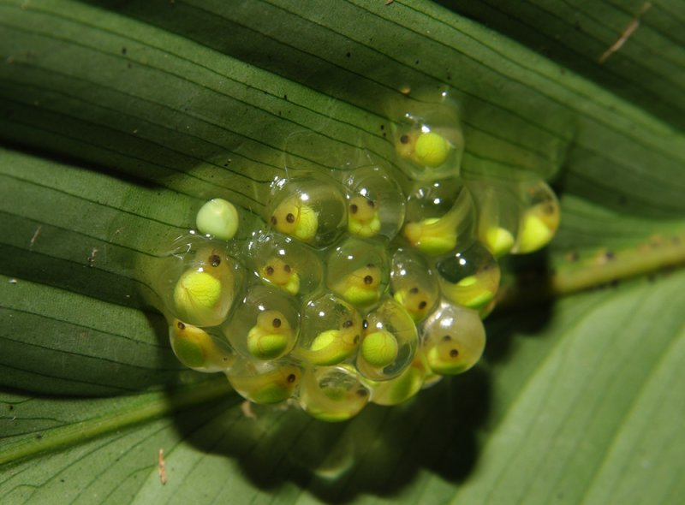

Practical Manual

**Development Biology**

**

**Faculty of Fisheries & Wildlife**

**University of Veterinary & Animal Sciences Lahore, Pakistan**

Waqas Ali

Teaching Assistant

Contents

|  |  |  |
| --- | --- | --- |
| **Serial No.** | **Title** | **Page No.** |
| 1 | Study of Structure of Frog gametes | 2 |
| 2 | Study of Structure of Fish gametes | 4 |
| 3 | Study of Structure of Fowl gametes | 6 |
| 4 | Study of anatomical Features Of 24-Hour Chick Embryo | 8 |
| 5 | Study of anatomical Features Of 33-Hour Chick Embryo | 10 |
| 6 | Study of anatomical Features Of 36-Hour Chick Embryo | 12 |
| 7 | Study of anatomical Features Of 48-Hour Chick Embryo | 14 |
| 8 | Study of anatomical Features Of 55-Hour Chick Embryo | 16 |
| 9 | Study of anatomical Features Of 72-Hour Chick Embryo | 18 |
| 10 | Study of anatomical Features Of 96-Hour Chick Embryo | 20 |
| 11 | Induced spawning of Fish | 22 |
| 12 | Breeding of Common Carp | 25 |
| 13 | Study of Histology Procedure | 27 |
| 14 | Study of histological examination of fish Heart | 30 |
| 15 | Study of histological examination of fish small intestine | 31 |
| 16 | Study of histological examination of fish Ovary and testis | 32 |

**PRACTICAL NO 1**

**STUDY OF STRUCTURE OF FROG GAMETES**

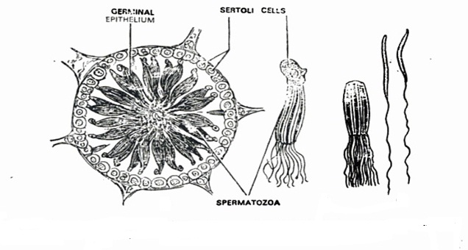

**Germinal Epithelium:** Inner layer of testis or wall of seminiferous tubules (where sperms produces)

**Sertoli Cells:** Somatic cells where spermatids develop (Immature Sperms)

**Spermatozoa**: Mature Sperms

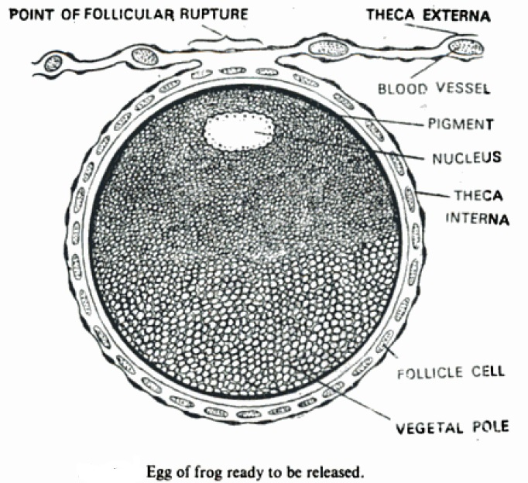

**Vegetal pole:** Where yolk is more than cytoplasm

**Theca interna:** Internal layer

**Theca externa:** Outer layer

**Follicle Cells:** Release hormones

**PRACTICAL NO 2**

**STUDY OF STRUCTURE OF THE FISH GAMETES**

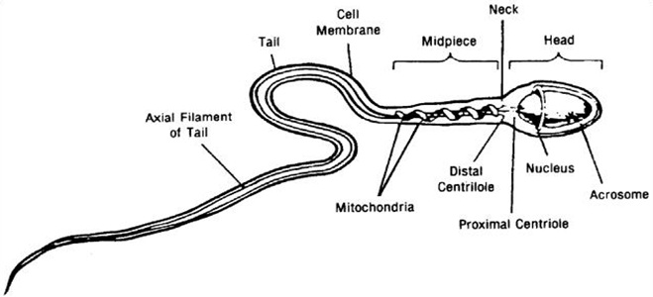**Sperm Structure of Fish**

**Acrosome:**  It is a cap-like structure which release enzyme. These enzymes break down the outer membrane of the ovum

**Proximal Centriole:**  Cylindrical cell structure composed mainly of a protein called tubulin.

**Egg Structure of Fish**

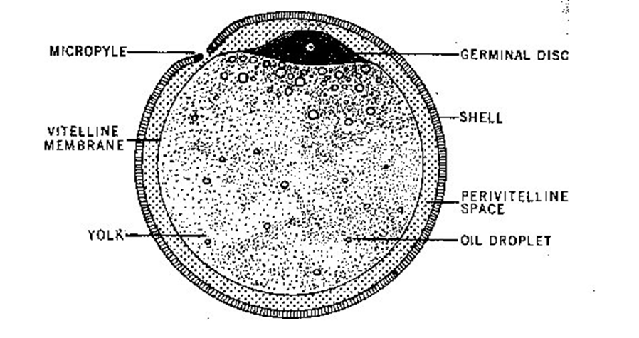

**Micropyle:** A pore in the membrane of the ovum of through which a sperm can enter.

**Germinal Disc:** refers to a round single-cell layer of cells from which the embryo is going to form.

**Vitelline membrane:** outer surface of the plasma membrane of an [ovum](http://en.wikipedia.org/wiki/Ovum). It is composed of protein fibers, with protein receptors needed for sperm binding which, in turn, are bound to sperm plasma membrane receptors.

**PRACTICAL NO 3**

**STUDY OF STRUCTURE OF THE FOWL GAMETES**

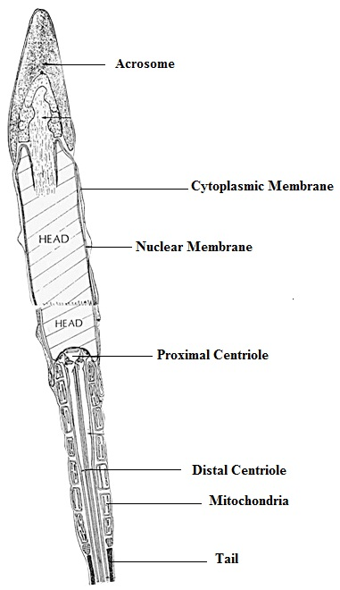

Diagrammatic representation of a longitudinal section through the acrosome and anterior part of the head of a fowl spermatozoon.

**Acrosome**: The acrosome is a cap-like structure over the sperm's head; which release enzyme to dissolve ovum membrane.

**Centriole:**  Cylindrical cell structure composed mainly of a protein called tubulin

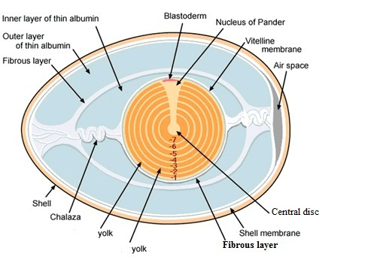

**Chalaza:** Spiral bands of tissue in an egg that connect the yolk to the lining membrane at either

End of the shell

**Blastoderm:** The layer of cells which later divides into the three germs layers (ecto,endo and mesoderm) from which the embryo develops. Also called germinal membrane.

**Nucleus of pander**: Flask-shaped mass of yolk in a bird's egg.

**Vitelline membrane:** Outer surface of the plasma membrane of an [ovum](http://en.wikipedia.org/wiki/Ovum). It is composed of protein fibers, with protein receptors needed for sperm binding which, in turn, are bound to sperm plasma membrane receptors.

**PRACTICAL NO 4**

**STUDY OF ANATOMICAL FEATURES OF 24-HOUR CHICK EMBRYO**

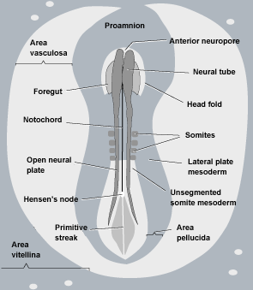

1. Two subdivisions of **Area Opeca**: The peripheral opaque area that surrounds vertebrate embryo formed by cleavage.

**Area Vitellina:** The outer non-vascular portion of the area opaca.

**Area Vasculosa:** The inner portion of the area opaca in which blood and blood-vessel formation occur.

1. **Hensen's Node:** Also known as the primitive knot is thickening of cells at the top of the primitive groove (narrow cut or depression) through which gastrulating cells migrate anteriorly to form tissues in the future head and neck.
2. There is unsegmented somites are present.
3. The clear head fold is anteriorly present.
4. Primitive streak is widened from posterior part.
5. Area Vasculosa is with traces of yolk.
6. At the cephalic region neural fold is present.

**PRACTICAL NO 5**

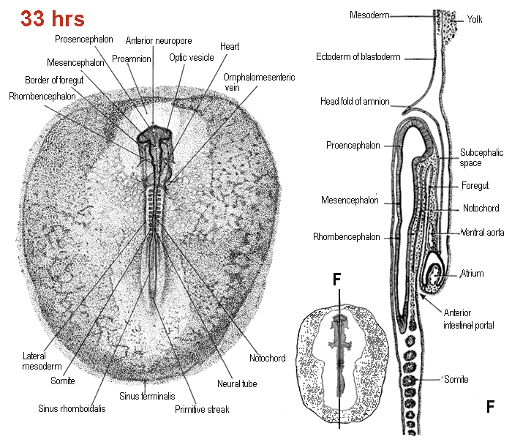**STUDY OF ANATOMICAL FEATURES OF 33-HOUR CHICK EMBRYO**

**THE ANATOMICAL FEATURES OF 33-HOUR CHICK EMBRYO**

1. Three major divisions of brain

* Pro-cencephalon,
* Mesencephalon and
* Rhombencephalon are distinguishable.

1. Notochord is distinct. (The notochord is a flexible rod-shaped body found in embryos of all chordates. It is composed of cells derived from the mesoderm and defines the primitive axis of the embryo)
2. There are 10 pairs of somites and elongated foregut is present.
3. Outgrowth of Optic vesicle is present and heart is found at the nearly right part.
4. Well-developed Vitelline vein is present and Mesoderm is un-segmented.

**PRACTICAL NO 6**

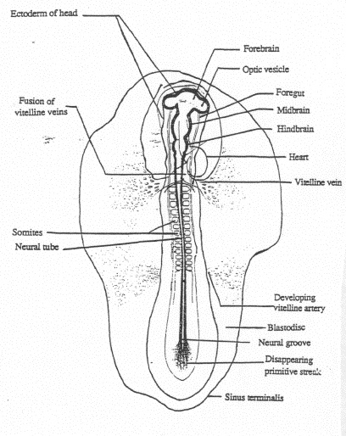**STUDY OF ANATOMICAL FEATURES OF 36-HOUR CHICK EMBRYO**

1. 36-hours after fertilization the heart is a S-shaped tube which is at the right of the embryo The further development of the heart is now mesodermal.
2. Fusion of vitelline veins.
3. The formation of blood of blood vessels.
4. Further development of brain into midbrain and hind brain.
5. Well-developed somites and neural tube.
6. Primitive streak starts to disappear.
7. Development of optic vesicle.

**PRACTICAL NO 7**

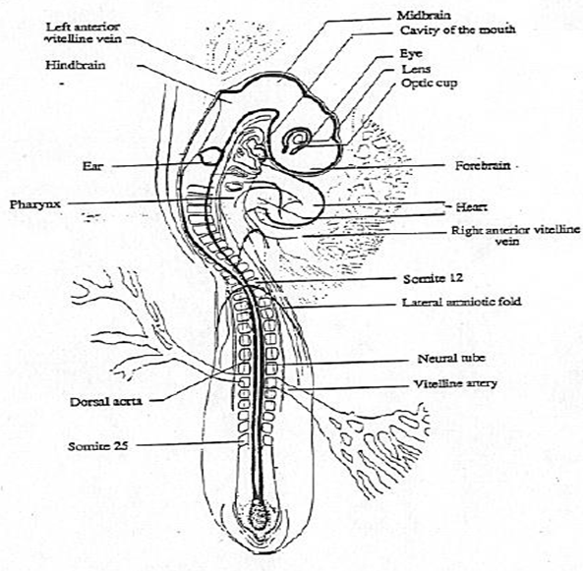**STUDY OF ANATOMICAL FEATURES OF 48-HOUR CHICK EMBRYO**

1. The position and size of the embryo with respect to the yolk changes strongly about 48 hours after fertilization.
2. In addition to the head fold the lateral and caudal amniotic folds begin to form.
3. The outgrowth of the cranial flexure is so strong that the forebrain and hindbrain vesicles become almost located to each other.
4. The cephalic region of the embryo is twisted in such a manner that the left side comes to lie next to the yolk. A second flexure appears at the transition of the head and the body just behind the heart region.
5. The embryo takes now the shape of a C. The head becomes covered by a double fold with amnion membrane.
6. The vitelline (yolk rich) arteries and veins become connected with the extra embryonic circulatory vessels.
7. The brain divides in to 5 vesicles: telencephalon and diencephalon (both formed by the division of the forebrain vesicle), mesencephalon, metencephalon and myencephalon (both formed by the division of the hindbrain vesicle).
8. The optic vesicle will become the optic cup and the auditory placode the auditory pit.
9. The heart differentiates in to 4 compartiments: the sinus venosus, connected with the veins, the atrium, the U-shaped ventricle.

**PRACTICAL NO 8**

**STUDY OF ANATOMICAL FEATURES OF 55-HOUR CHICK EMBRYO**

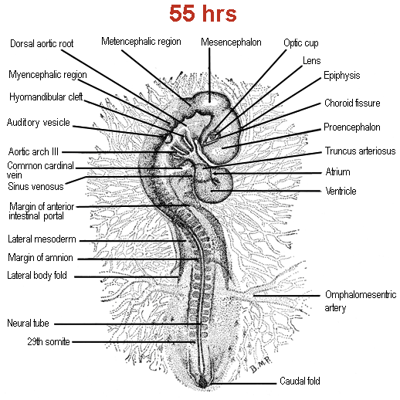

**THE ANATOMICAL FEATURES OF 55-HOUR CHICK EMBRYO**

1. 27-30 pairs of somites are present.
2. Optic cup is totally formed.
3. Tail bud is developed.
4. Both cranial and cervical flexures are developed.
5. Heart is well-developed.
6. Eye lens is formed.
7. Lateral fold is present.

**PRACTICAL NO 9**

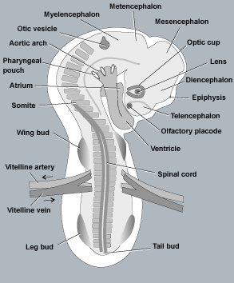**STUDY OF ANATOMICAL FEATURES OF 72-HOUR CHICK EMBRYO**

**THE ANATOMICAL FEATURES OF 72-HOUR CHICK EMBRYO**

1. Well-formed Spinal cord.
2. Cranial flexure is very distinct.
3. Olfactory placode is well developed.
4. Lens formed in the optical vesicles.
5. In heart, well developed atrium and ventricle are present.
6. Pharyngeal pouches and Aortic arches are well developed.

**PRACTICAL NO 10**

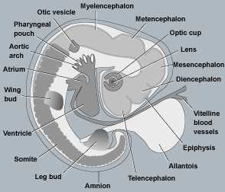**STUDY OF ANATOMICAL FEATURES OF 96-HOUR CHICK EMBRYO**

1. Development of inner ear.
2. The nasal placode (or olfactory placode) gives rise to the [olfactory epithelium](http://en.wikipedia.org/wiki/Olfactory_epithelium) of the [nose](http://en.wikipedia.org/wiki/Human_nose).
3. Pharyngeal or branchial pouches are present.
4. The pouches line up with the clefts and these thin segments become [gills](http://en.wikipedia.org/wiki/Gills) in [fish](http://en.wikipedia.org/wiki/Fish).
5. Aortic arches development.
6. Presence of Allantois.
7. Development of wings and legs bud.

**PRACTICAL NO 11**

**INDUCED SPAWNING OF FISH**

Indian major carp spawn only during monsoon season and in the running water of the rivers and streams. They do not spawn in stagnant water or under laboratory conditions. They readily spawn following administration of crude pituitary extract or purified or partially purified protein hormones. Therefore, these fishes are also called difficult to spawn fishes.

**A) Induced breeding using pituitary injections**

Houssay (1931) was the first scientist to describe this method

**Materials**

1. Brood fish/spawners
2. Pituitary glands/ovaprim

**Procedure**

* A few months before the onset of spawning season, male and female breeders are sorted out and stocked separately In fertilized ponds @ 1000-2000/ hac.
* Feed the fish on groundnut oilcake and rice bran (1:1) @ 1-2% of total body weight.
* Select the fish (Indian major carp) weighing 1.5-5.0 kg, identify the sexes
* Handle the breeders carefully. Selected breeders are collected with hand nets and weighing individually for calculating the doses of pituitary extract (PE)
* Take out few eggs from the female brood fish using a catheter. Dip the eggs in a solution of acetic acid (70%) and (30%) for five minutes. Observe the nucleus under the microscope, if the nucleus is in the centre, fish is ready for spawning
* Inject the pituitary extract in intramuscularly at any of the sides of the brood fish such as the base of pectoral fin, axil of the pelvic fin, below the dorsal or below the lateral line or caudal peduncle
* Give two injection (a preparatory or provocative dose@2-3mg kg and second injection or resolving dose @5-8mg kgbody weight four hours after the first injection) to females
* After injection, introduce the male and female breeders into breeding hapa
* Observe the sexual play of the breeders
* Spawning is normally, observed after 3-6 hour which is influenced by low temperature, rain water, slight drizzling and cool weather
* If spawning does not occur within 3-6 hours give a third injection of higher dose to the female breeders
* Observe transparent and non-adhesive eggs of about 3-5 mm in diameter.

**B) Induce breeding using ovaprim**

Ovaprim is a spawning hormone. Each ml of ovaprim contains 20 µg of salmon GtHRH and 10 mg of domperidone.

* Take out few eggs from the female brood fish using a catheter and dip the eggs in solution of 70% acetic acid and 30% alcohol for five minutes
* Observe the nucleus under the microscope, if the nucleus is not in the center the fish is not ready for spawning
* Give only one injection simultaneously to the male and female fish
* For females of Indian major carps 0.25 to 0.5 ml kgbody weight and for males 0.1 to 0.2 ml kgbody weight gives good results.
* Transfer the male and female fishes separately to circular tanks in hatchery.
* Strip the male and female fish after 6-8 hours in a container and mix milt and eggs with birds feathers.
* After fertilization, do water Harding to the fertilized eggs for 15 to 20 mins.
* Then transfer the eggs to circular tanks.
* Hatchling will remain in the tank for 2-3 days depends upon their yolk consumption.
* After 2-3 days transfer hatchling to nursery ponds.

**PRACTICAL NO 12**

**BREEDING OF COMMON CARP, *CYPRINUS CARPIO***

Common carp breeds almost throughout the year, even in stagnant/confined waters. However, 2-3 (February-March, September-October) major peaks can be observed during its reproductive cyclicity and no hormonal injections are normally required to breed the fish.

**Methodology:**

* Segregate the female and female brooders a few months/ (2-3 months) prior to the breeding season
* Stock the brood fish (male and female) in separate ponds (which are free from other fishes)
* Feed the brood fish on a mixture of oilcake and rice bran (1:1) @ 2-3% of their body weight
* If there is any algal bloom in the ponds suspend feeding immediately, while keeping a watch on the health of the breeders

Breed the fish as followings:

**Hapa Breeding:**

* Fix the hapa in the ponds with the help of four bamboo sticks.
* Introduce common submerged aquatic weeds like Hydrilla, najas, potomogeton @ 2 kg of weeds per one Kg of the weight of the female fish as egg stickers.
* Release the brood fish in the hapa preferably in the evening (1 female and 2 or 3 males) keeping the total weight of males almost equal to the females.
* Observe spawning in the next morning
* Remove the brooders.
* If you want to record the fecundity, take the weight of the fish before releasing for spawning and after spawning. Record the differences in weight.
* Differentiate between the viable (fertilized) eggs from the dead ones. Dead eggs are opaque while fertilized eggs are transparent.
* Instead of hapas, cement cisterns (tank for storing water) can also be employed for breeding purposes.

**Pond breeding**

* Breeding can also be done in ponds by providing bundles of the aquatic weeds.
* Make strings of weeds by tieing with ropes. You can give any shape.

**PRACTICAL NO 13**

**STUDY OF HISTOLOGY PROCEDURE**

Collect the samples and freeze the samples at 00C.

**Fixation**

Fish fry sample (control and treated groups) were fixed in Bouin’s fluid. Bouin’s fixative as described by Humason (1962) has the following constituents.

* 1. Picric acid saturated aqueous 75.0 ml
  2. Formalin 25.0 ml
  3. Glacial acetic acid 05.0 ml

**Dehydrating and Embedding**

* Washed samples with 70% alcohol(ethanol) for 24 hrs
* Soaked the samples to the following for 15mins each
* 80% alcohol (ethanol)---15 mins
* 90% alcohol (ethanol)---15 mins
* 95% alcohol (ethanol)---15 mins

**Paraffin**

* Soaked with xylene ---20-30mins7
* Replaced with 50:50 (xylene and soft paraffin)--- 2hrs at 600C oven
* Replaced with soft paraffin --- 6hrs at 600C oven
* Replaced with hard paraffin--- 24hrs at 600C oven

**Embedding Sectioning and mounting**

* Used microtome 2-3 um
* Placed the cut specimen in the slide with Meyer’s albumin.
* Contents of Mayer’s albumen, as described by Hamson (1962) are as follows:

1. Egg albumen 50 ml
2. Glycerol 50 ml
3. Formalin 0.1 ml

**Staining**

**Staining Reagents**

* 1. Hematoxylin

Formula of the stain as described by Delafield (1855) was as follows:

1. Hematoxylin (powder) 1.0 gm
2. Distilled water 1.0 liter
3. Sodium iodate 2.0 gm
4. Potassium Alum 50 gm
5. Citric acid 1.0 gm
6. Chloral hydrate 50.0 gm

**Procedure for Preparation of Hematoxylin Stain**

1. Dissolved 1.0 gm haematoxylin powder in 1L of distilled water, heated it gently.

ii) Added 2.0 gm sodium iodate and 50.0 gm potassium alum. Heated the mixture until dissolved.

iii) Added 1.0 gm citric acid and 50 gm chloral hydrate.

* 1. Eosin: Putt’s (1948)

Formula of Eosin is as follows:

1. Eosin (powder) 1.0 gm
2. Potassium dichromate 0.5 gm
3. Aquous picric acid (saturated) 10.0 ml
4. Distilled water 80.0 ml
5. Glacial acetic acid (optional) 1 drop

**Procedure for Preparation of Eosin Stain**

1. 1.0 gm eosin (powder) was dissolved in 10.0 ml absolute ethyl alcohol.
2. 10.0 ml of saturated picric acid was added after the eosin was dissolved completely.
3. Then added 0.5 gm of potassium dichromate (K2 Cr2 O7) to the mixture.
4. The stain was diluted by the addition of 80.0 ml of distilled water.
5. After the preparation of the stain, one drop of glacial acetic acid was added.

**Staining procedure**

* + - Slides were deparrafinized in water bath with xylol
    - Soaked with 100 % alcohol (ethanol) for 3mins
    - Soaked with 95% alcohol (ethanol) for 3mins
    - Soaked with 80% alcohol (ethanol) for 3mins
    - Soaked with 70% alcohol (ethanol) for 3mins
    - Soaked with 50% alcohol (ethanol) for 3mins
    - Washed with water
    - Stained with hematoxyline for 1min
    - Washed with water
    - Soaked with 70% alcohol (ethanol) for 3mins
    - Soaked with 90% alcohol (ethanol) for 3mins
    - Stained with eosin
    - Soaked with 95% alcohol (ethanol) for 3mins
    - Soaked with 100% alcohol (ethanol) for 3mins
    - Soaked in xylene for 5mins
    - Blow dried in air
    - Dipped again in xylene for 5mins
    - Added clove oil and put cover slip carefully
    - Mounted in canada balasum

**PRACTICAL NO 14**

**STUDY OF HISTOLOGICAL EXAMINATION OF FISH HEART**

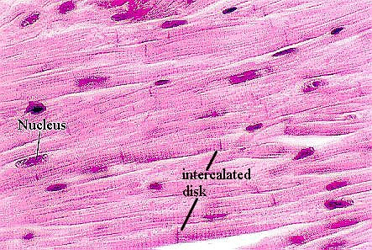

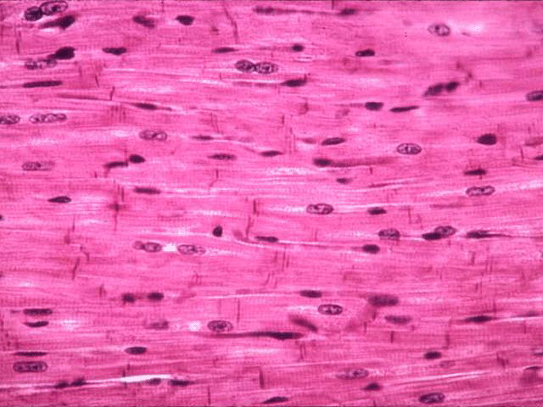

**PRACTICAL NO 15**

**STUDY OF HISTOLOGICAL EXAMINATION OF FISH SMALL INTESTINE**

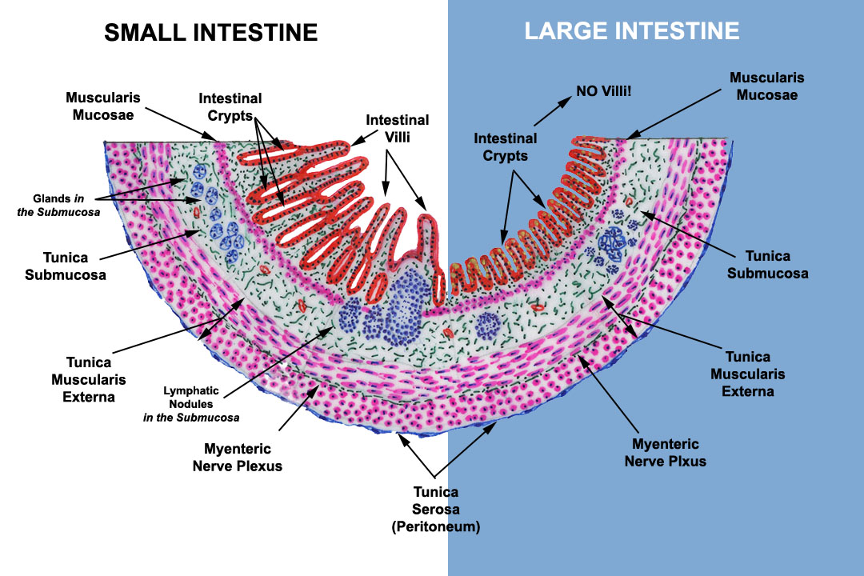

**PRACTICAL NO 16**

**STUDY OF HISTOLOGICAL EXAMINATION OF FISH OVARY AND TESTIS**

