**PRACTICAL NO 1**

**STUDY OF MITOSIS IN ONION ROOT TIP**

**What is mitosis?**

Mitosis produces two daughter cells that are identical to the parent cell. If the parent cell is haploid (N), then the daughter cells will be haploid.

If parent cell is diploid, the daughter cells will also be diploid.

N N

2N 2N

This type of cell division allows multicellular organisms to grow and repair damaged tissue.

Summary of the phases of mitosis:

* All new cells come from previously existing cells.
* New cells are formed by the process of cell division which involves both replication of the cell’s nucleus (karyokinesis) and division of the cytoplasm (cytokinesis) to form two genetically identical daughter cells.
* There are two types of nuclear division: mitosis and meiosis.
* Mitosis typically results in new somatic (body) cells.
* Formation of an adult organism from a fertilized egg, asexual reproduction, regeneration, and maintenance or repair of body parts is accomplished through mitotic cell division.
* Meiosis, on the other hand, results in the formation of either gametes (in animals) or spores (in plants). These cells have half the chromosome number of the parent cell.

**Materials**

* Microscope
* Blade
* Slides with cover sip
* Onion root tips
* 1M/0.1N HCL
* Forceps
* Aceto orcein/Acetocarmine stain

**Procedure**

**Preparing an onion root tip squash**

* It is possible for you to make your own stained preparations of onion root tips and observe mitotic figures.
* Onion bulbs have been rooted in water.
* Growth of new roots is due to the production and elongation of new cells.
* Mitotic divisions are usually confined to the cells near the tip of the root.
* Follow the procedure outlined below to make your own root tip preparation.
* Obtain an onion bulb that has been rooted in water. Cut 2 or 3 roots off near the base of the bulb.
* Then, cut off the bottom 1 or 2 mm of the root tip and place it in a petri plate. With a Pasteur pipette, add a small puddle of 1M/0.1N HCl (You can incubate it).
* Remove the root tip from the HCl with forceps and place on a slide.
* Wash the tips with tap water to remove acid and place it on clean slide
* Add 2-3 drops of aceto orcein stain
* Give longitudinal cut with sharp razor blade
* 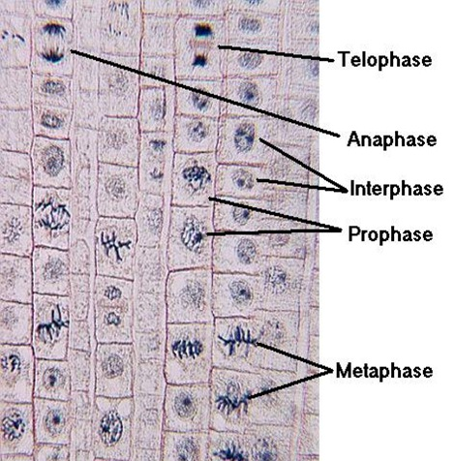Place the slide, cover slip down on a paper towel. Using a pencil eraser, carefully apply pressure to the cover slip area in order to squash and spread the root tip tissue. [This takes a little practice, so if your first squash does not yield good results, try another one or two.
* Mount the slide on your microscope.
* Use the low power objective on your microscope to look for thin layers of cells and then use the 10-40X power objective to observe mitotic stages in individual cells.
* Identify chromosomes at the various stages of mitosis.
* Compare your slide to the prepared slides that contain stained sections of root tips.
* Make sketches of the mitotic stages observed.

**Observation**

The phases of plant mitosis are:

**Interphase:** The non-dividing cell is in a stage called interphase. The nucleus may have one or more dark-stained nucleoli and is filled with a fine network of threads, the chromatin. Interphase is essential to cell division because the genetic material (DNA) is duplicated (replicated) during this stage.

**Prophase:** The first sign of a division is prophase, in which a thickening of the chromatin threads occurs. Thickening continues until it is evident that the chromatin has condensed into chromosomes. With somewhat higher magnification you may be able to see that each chromosome is composed of two chromatids. As prophase continues, the chromatids continue to shorten and thicken. In late prophase the nuclear envelope and nucleoli are no longer visible, and the chromosomes are free in the cytoplasm. Just before this time the first sign of a spindle appears in the cytoplasm; the spindle apparatus is made up of microtubules, and it is thought that these microtubule may pull the chromosomes toward the poles of the cell where the two daughter nuclei will eventually form. It appears that centrioles are basal bodies that give rise to flagella and cilia in animals and lower plants such as mosses and ferns. Centrioles are not found in no flagellated “higher” plants such as angiosperms.

**Metaphase:** At metaphase, the chromosomes have moved to the center of the spindle. One particular portion of each chromosome, the centromere, attached to the spindle. The centromeres of all the chromosomes lie at about the same level of the spindle, on an imaginary plane called the metaphase plate. At metaphase you should be able to observe the two chromatids of some chromosomes.

**Anaphase:** At the beginning of anaphase, the centromere regions of each pair of chromatids separate and are moved by the spindle fibers toward opposite poles of the spindle, dragging the rest of the chromatid behind them. Once the two chromatids separate, each is called a chromosome. The daughter chromosomes continue pole ward movement until they form two compact clumps, one at each spindle pole.

**Telophase:** Telophase, the last stage of division, is marked by a pronounced condensation of the chromosomes, followed by the formation of a new nuclear envelope around each group of chromosomes. The chromosomes gradually uncoil to form the fine chromatin network of interphase, and the nucleoli and nuclear envelope reappear. The cell develops into two new cells. In plants, a new cell wall is laid down between the daughter cells. In animal cells, the old cell will pinch off in the middle to form two new daughter cells. This division of the cytoplasm, in contrast to nuclear division 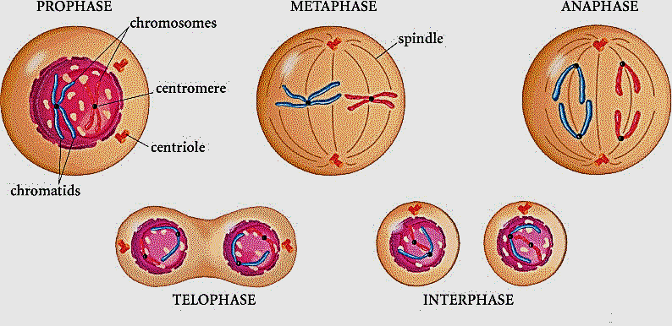(mitosis), is called cytokinesis.