Practical 6

General morphology of *Drosophila melanogaster*

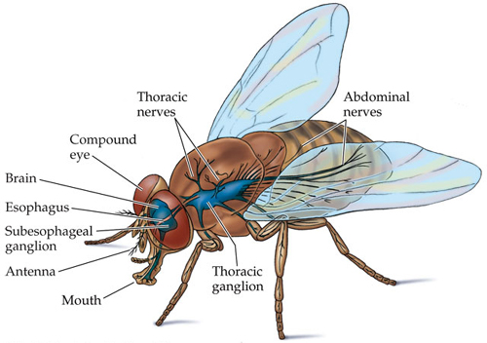

**Geographic Range**

* *Drosophila melanogaster* has been introduced to every continent of the world with one exception, Antarctica.
* Humans have helped to spread *Drosophila melanogaster* to every other location which it inhabits.

**Geographic distribution:** Cosmopolitan

**Habitat**

* *Drosophila melanogaster* lives in a wide range of habitats.
* Native habitats include those in the tropical ([tropical climate](http://en.wikipedia.org/wiki/Tropical_climate) to mean warm to hot and moist year-round, often with the sense of lush vegetation) regions,
* But the common fruit fly has been introduced to almost all temperate (The temperatures in these regions are generally relatively moderate, rather than extremely hot or cold, and the changes between [summer](http://en.wikipedia.org/wiki/Summer) and [winter](http://en.wikipedia.org/wiki/Winter) are also usually moderate) regions of the world.
* The only aspects that limit the habitats *Drosopila melangaster* can live in is temperature and availability of water.
* The scientific name Drosophila **actually means** "lover of dew", implying that this species requires moist environments.
* The development of this species' offspring is extremely dependent on temperature, and the **adults cannot** withstand the colder temperatures of high elevations or high latitudes.
* Food supplies are also limited in these locations. Therefore, in colder climates *Drosophila melanogaster* cannot survive.
* In **temperate regions** where human activities have introduced *Drosophila melanogaster*, these flies seek shelter in colder winter months.
* Many times Drosophila can be found in fruit cellars, or other available man-made structures with a large supply of food.

**Habitat Regions**: temperate, tropical, terrestrial

**Physical Description**

* Drosophila mature through complete metamorphosis, as do all members of the order Diptera (from the Greek di = two, and ptera = wings.
* 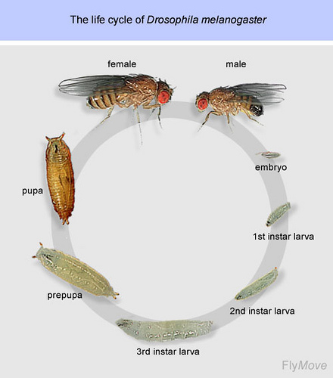
* Similar to all insects Drosophila is covered in a chitinous exoskeleton; has three main body segments; and has three pairs of segmented legs.

ADULT:

* The common fruit fly is normally a yellow brown (tan) color, and is only about 3 mm in length and **2 mm in width**.
* The shape of the common fruit fly's body is what one would normally imagine for a species of the order Diptera.
* It has a rounded head with large, red, compound eyes**;
* ** Arthropod eyes are called **compound eyes** because they are made up of repeating units, the **ommatidia**, each of which functions as a separate visual receptor.

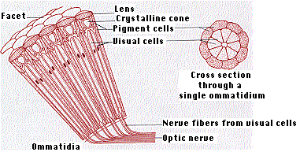

Each ommatidium consists of

* a **lens** (the front surface of which makes up a single **facet**)
* a transparent **crystalline cone**
* light-sensitive **visual cells** arranged in a radial pattern like the sections of an orange
* **pigment cells** which separate the ommatidium from its neighbors.
* 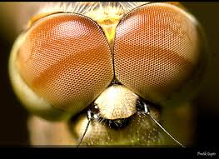
* and short antennae.
* Its mouth has developed for sopping up liquids.
* The female is slightly larger than the male.
* There are black stripes on the dorsal surface of its abdomen, which can be used to determine the sex of an individual.
* Males have a greater amount of black pigmentation concentrated at the posterior end of the abdomen.
* Like other flies, *Drosophila melanogaster* has a single pair of wings that form from the middle segment of its thorax.
* Out of the last segment of its throax (which in other insects contains a second pair of wings) develops a set rudimentry wings that act as knobby balancing organs. These balancing organs are called halteres.
* Larvae are minute white maggots lacking legs and a defined head

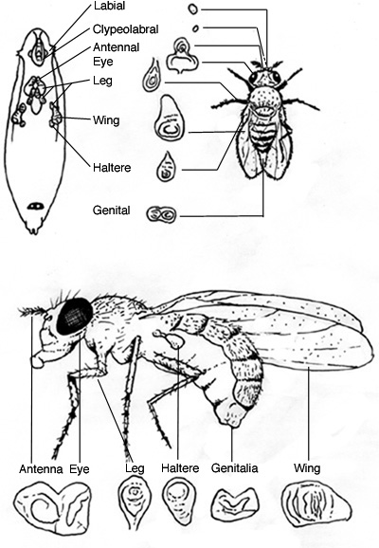

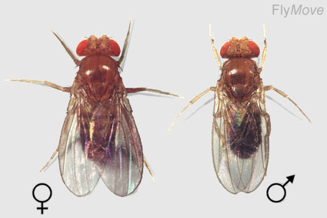

[**How to Distinguish Between Male and Female Fruit Flies**](http://www.wikihow.com/Distinguish-Between-Male-and-Female-Fruit-Flies)

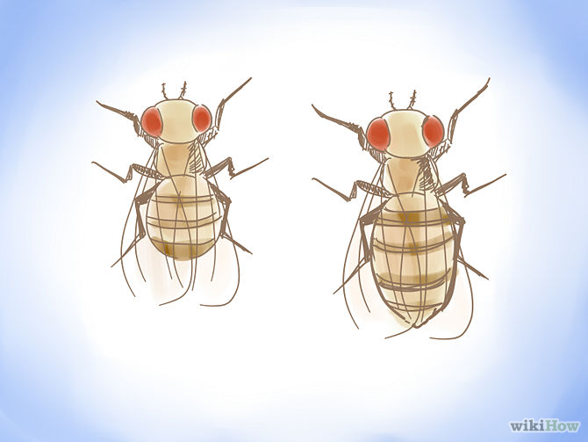

**Look at the size of the fly.** This is the first and most basic step towards distinguishing the gender of your Drosophila. Female flies tend to be much larger than male flies. If you look at the cartoon above, you can see that the female is about 25% larger than the male. This method is not always foolproof, so you have to be willing to look a little deeper into the differences.

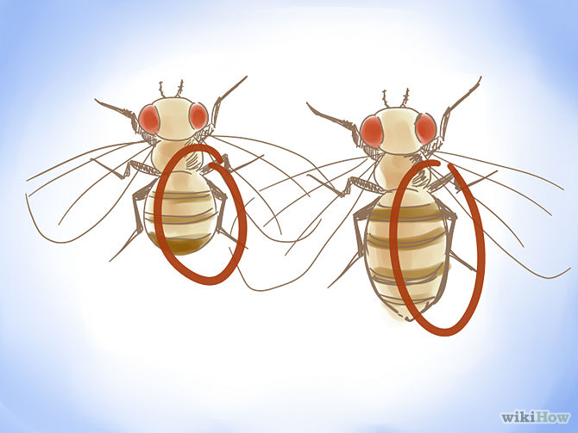

**Look at the color of the abdomen.** A fly's abdomen is made up of many different segments. On a male fly, the last two segments of the abdomen are much darker than the female.

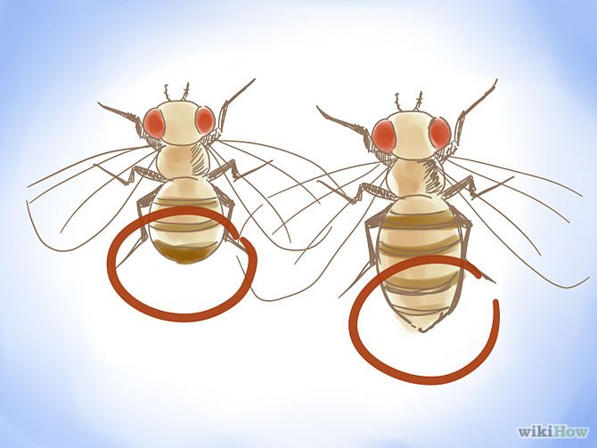

**Look at the shape of the abdomen.** While you're looking at the color of the last two segments of the abdomen, look at the shape of it. The male's abdomen is rounded at the bottom while the female's abdomen is pointed.

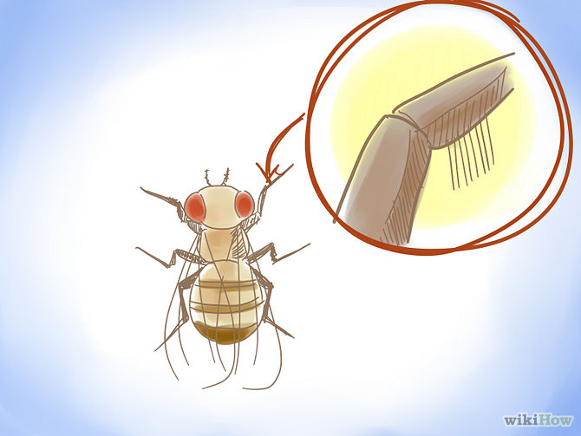

**Use a microscope to observe the sex combs.** This is the best way to distinguish between males and females in that sex combs are always present, however it is the hardest to see. In order to see sex combs, you will likely need some sort of microscope. A high magnification microscope is unnecessary, just a basic 10x microscope. Sex combs are located on the forelegs of male flies and look like thick black lines right before the joint. If you look closer, you can see that they are raised a little bit off of the leg and pointed on the end. Sex combs are used to latch onto the female whilst attempting to mate.