**PRACTICAL NO 7**

**SALIVARY GLAND CHROMOSOMES OF *DROSOPHILA MELANOGASTER***

**Introduction**

* *Drosophila melanogaster*, or the red-eyed fly, is classified in the family Drosophilidae, and order Diptera (two winged,which also includes flies, mosquitoes and midges.).
* *Drosophila* has been such a model organism for several reasons. They are small, easy to raise in the Lab, have a short life-cycle, have only 4 pair of chromosomes, and contain large polytene (Polytene chromosomes are over-sized [chromosomes](http://en.wikipedia.org/wiki/Chromosomes) which have developed from standard chromosomes and are commonly found in the salivary glands of [*Drosophila melanogaster*](http://en.wikipedia.org/wiki/Drosophila_melanogaster). Specialized cells undergo repeated rounds of [DNA replication](http://en.wikipedia.org/wiki/DNA_replication) without [cell division](http://en.wikipedia.org/wiki/Cell_division)([endomitosis](http://en.wikipedia.org/wiki/Mitosis" \o "Mitosis)), to increase [cell](http://en.wikipedia.org/wiki/Cell_(biology)) volume, forming a giant polytene chromosome. Polytene [chromosomes](http://en.wikipedia.org/wiki/Chromosome) form when multiple rounds of replication produce many sister [chromatids](http://en.wikipedia.org/wiki/Chromatid) that remain synapsed together.) chromosomes.
* Polytene chromosomes, found in the salivary glands of organisms in the order, Diptera, are actually 1,000s of copies of each chromosome lined up in register.
* Areas of dark and light bands contain various concentrations of DNA and protein in the chromatin, and can be seen under a light microscope at a magnification of 450X

**Materials**

* Drosophila population, males and females
* Culture tubes with food at the bottom
* Breathable cotton material for tube stopper
* Ether (and eye dropper for transferring ether to sleep box)
* Dissecting microscope or hand lens
* Soft, small paint brush for moving etherized flies
* White paper (index card) on which to view the flies
* Compound Microscope (Light)

**Procedure**

Dissection of the salivary glands and polytene chromosome preparation

1. Place a few drops of insect Ringers (NaCl. 7.5 gm. KCl. 0.35 gm. CaCl2. 0.21 gm) or Saline in a well of a depression slide, watch glass, or small Petri plate.
2. Select a third instar larva from your bottle; they will be found near the bottom of the bottle, as they are just beginning to crawl up the sides.  If the one you have chosen is sessile, it has already pupated and is of too late a stage to be used.  Remove the larva with a pair of forceps or a dissecting needle and place in the well of your slide.
3. 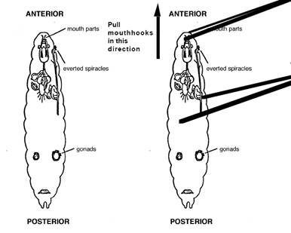Under intermediate power of the dissecting microscope, place one forceps firmly across the rear half of the larva to prevent movement.  Place the second forceps just behind the mouth hooks at the head region.  The head is sharply pointed and the mouth hooks are black and so should be distinguishable from the rear of the larva.
4. Pull the head off the body by firmly pulling the two forceps apart.  If you are successful, you should see the head with the two attached salivary glands trailing behind.  The salivary glands can be recognized as two long, transparent, sausage-shaped bags with a characteristic translucent fat body along one side and occasionally capping each gland.  Always keep the gland moist in Ringers solution.
5. 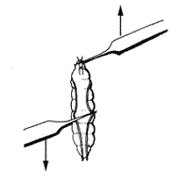Transfer the glands immediately into a drop of 45% acetic acid placed on a microscope slide.  Allow to remain approximately 30-45 seconds.  Be sure not to let the glands dry out.
6. Then transfer the glands to a small drop (2-3 mm in diameter) of aceto orcein stain in the center of the same slide.  This should all be done under the dissecting scope to insure that the glands don't stick to the forceps.  Leave them in the stain for 15-20 minutes (If the chromosomes aren't stained darkly enough, a longer incubation period may be necessary, last year 30 minutes worked well).  Again, make sure the stain doesn't dry out during this time period.
7. Gently place a coverslip over this preparation.  Put a piece of blotter paper over the coverslip and place a piece of parafilm over the blotter paper.
8. Place your thumb on the parafilm directly over the coverslip and press straight down quite firmly for about 20 seconds.  You do not want the coverslip to move relative to the slide.
9. Examine the slide under 10X to locate the squashes.  Then, look under 40X to find a good preparation.  Ideally, the chromosomes should be well spread and the bands stained darkly.  Once you have found such a squash, place a drop of oil on top of the coverslip and examine under 100X.  Now, try to identify the chromosomes based on the landmarks familiar to you.

**Observation**

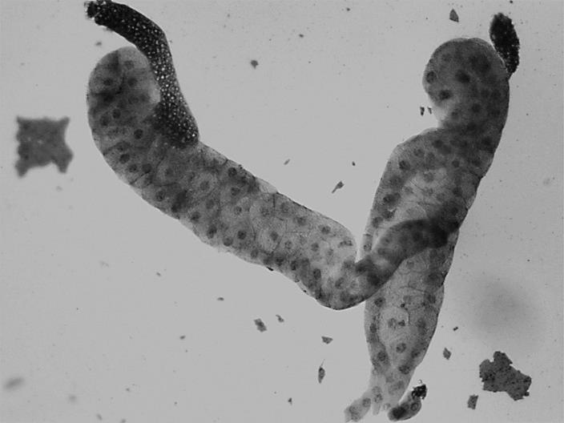Drosophila salivary glands chromosomes