**HUMAN PEDIGREE ANALYSIS PROBLEMS**

A **pedigree chart** is a diagram that shows the occurrence and appearance or [phenotypes](http://en.wikipedia.org/wiki/Phenotype) of a particular gene or [organism](http://en.wikipedia.org/wiki/Organism) and its [ancestors](http://en.wikipedia.org/wiki/Ancestor) from one generation to the next.

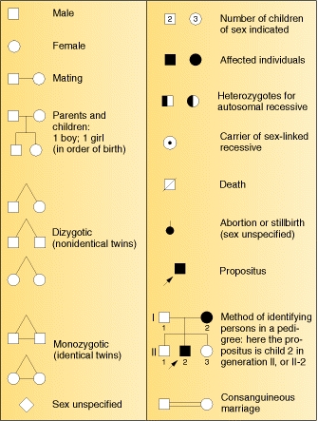The investigator traces the history of some variant phenotype back through the history of the family and draws up a family tree, or pedigree, using the standard symbols given in Figure.

**Pedigree Analysis Rules**

These pedigree analysis rules are based on the assumption that the disease is rare in the population. When looking at the sex linked inheritance, we will be looking at X linked inheritance patterns.

**Autosomal Dominant Inheritance**

* Trait should not skip generations (unless penetrance).
* An affected person married to a "normal" person should have approximately 50% of the offspring being affected. (Also indicates that the affected individual is heterozygous).
* Distribution of the trait should be close to equal distribution among the sexes.

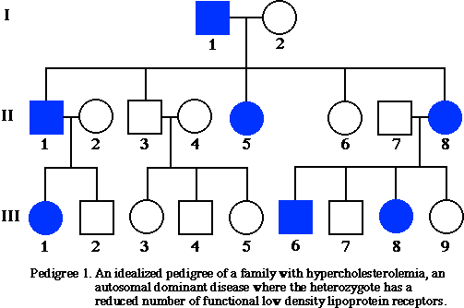

**Autosomal Recessive Inheritance**

* Trait often skips generations.
* Distribution of the trait should be close to equal distribution among the sexes.
* Traits are often found in pedigrees with consanguineous marriages.
* If both of the parents are affected, all of the children should be affected.
* Most affected individuals have "normal" parents.
* When a "normal" person is married to an affected individual, all of the children are normal (indicating the normal parent is homozygous dominant).
* If a "normal" person is married to an affected individual and one or more of the children is affected, then approximately half of the children should be affected. (Showing that the "normal" parent is heterozygous).

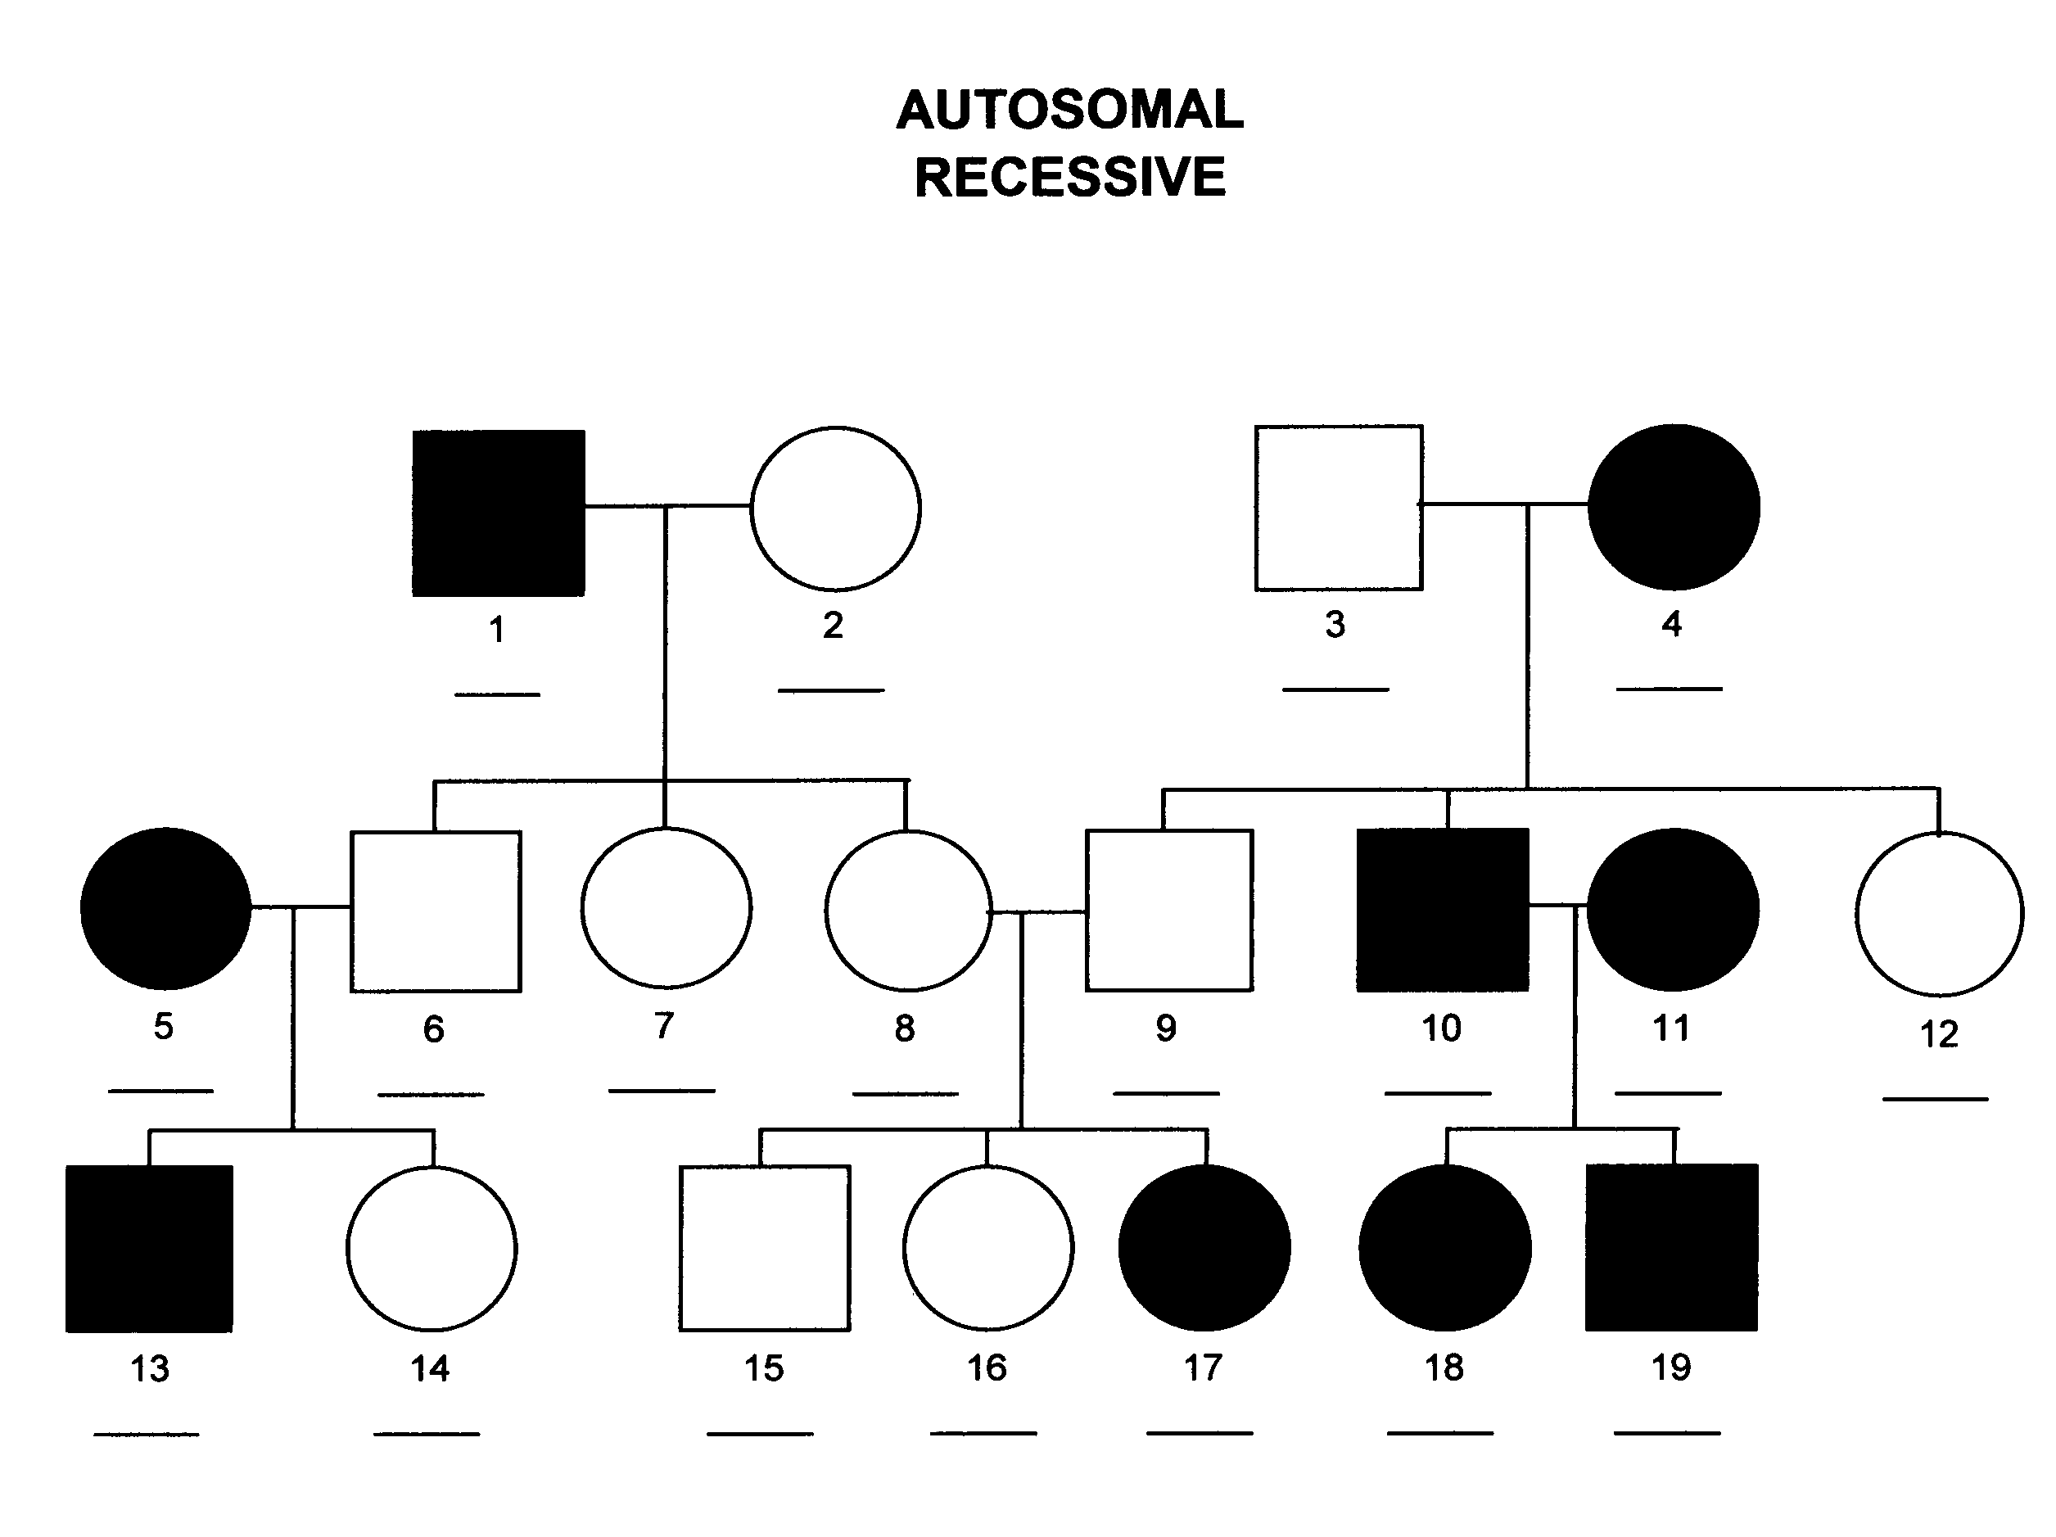

**Sex linked Dominant Inheritance**

* Trait should not skip generations (unless penetrance).
* Affected males must come from affected mothers.
* Approximately half of the children of an affected female are affected. (Figuring the mother is heterozygous)
* All the daughters, but none of the sons, of an affected father are affected.
* For a female child to be affected, the father or the mother must be affected.

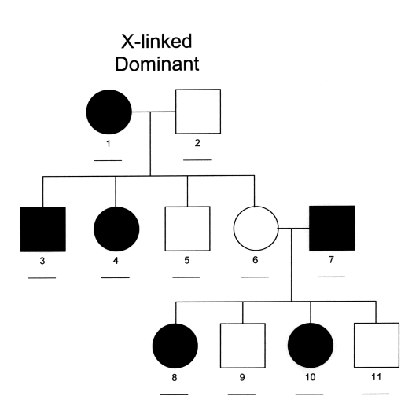

**Sex linked Recessive Inheritance**

* Most of the affected individuals are males.
* For a female child to be affected, the father must be affected and the mother must be affected or a carrier.
* All of the sons of an affected mother must be affected.
* For a male child to be affected, the mother must be affected or a carrier. (Many times this can be determined by studying males in the mothers family line)
* Approximately half of the sons of carrier females should be affected.

