**Types of Extreme Environments**

* [**Alkaline**](http://serc.carleton.edu/microbelife/extreme/alkaline/index.html): broadly conceived as natural habitats above pH 9 whether persistently, or with regular frequency or for protracted periods of time.
* [**Acidic**](http://serc.carleton.edu/microbelife/extreme/acidic/index.html): broadly conceived as natural habitats below pH 5 whether persistently, or with regular frequency or for protracted periods of time.

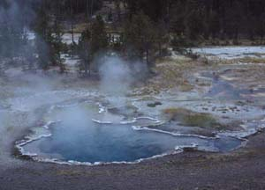

Octopus Spring is an alkaline hot spring, located in Yellowstone National Park, that supports the growth of thermophilic bacteria. [Details](http://serc.carleton.edu/details/images/2712.html)

* [**Extremely Cold**](http://serc.carleton.edu/microbelife/extreme/cold/index.html): broadly conceived habitats periodically or consistently below 5°C either persistently, or with regular frequency or for protracted periods of time. Includes montane sites, polar sites, and deep ocean habitats.
* [**Extremely Hot**](http://serc.carleton.edu/microbelife/extreme/extremeheat/index.html): broadly conceived habitats periodically or consistently in excess of 40°C either persistently, or with regular frequency or for protracted periods of time. Includes sites with geological thermal influences such as Yellowstone and comparable locations worldwide or deep-sea vents.
* [**Hypersaline**](http://serc.carleton.edu/microbelife/extreme/hypersaline/index.html): (high salt) environments with salt concentrations greater than that of seawater, that is, >3.5%. Includes salt lakes.
* [**Under Pressure**](http://serc.carleton.edu/microbelife/extreme/pressure/index.html): broadly conceived as habitats under extreme hydrostatic pressure—i.e. aquatic habitats deeper than 2000 meters and enclosed habitats under pressure. Includes habitats in oceans and deep lakes.

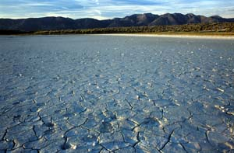

Alkaline Lake, of the Eastern Sierras, is shown above with a soft, gelatinous microbial mat forming over the surface. [Details](http://serc.carleton.edu/details/images/2711.html)

* [**Radiation**](http://serc.carleton.edu/microbelife/extreme/radiation/index.html): broadly conceived as habitats exposed to abnormally high radiation or of radiation outside the normal range of light. Includes habitats exposed to high UV and IR radiation.
* [**Without Water**](http://serc.carleton.edu/microbelife/extreme/withoutwater/index.html): broadly conceived as habitats without free water whether persistently, or with regular frequency or for protracted periods of time. Includes hot and cold desert environments, and some endolithic habitats.
* [**Without Oxygen**](http://serc.carleton.edu/microbelife/extreme/withoutoxygen/index.html): broadly conceived as habitats without free oxygen - whether persistently, or with regular frequency, or for protracted periods of time. Includes habitats in deeper sediments.
* [**Altered by Humans**](http://serc.carleton.edu/microbelife/extreme/altered/index.html): heavy metals, organic compounds; anthropogenically impacted habitats. Includes mine talings, oil impacted habitats.
* [**Astrobiology**](http://serc.carleton.edu/microbelife/extreme/astrobiology/index.html): Addresses life beyond the known biosphere—inclusive of life on other heavenly bodies, in space etc. Includes terraforming.

**Examples of Extreme Environments**

[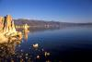](http://d32ogoqmya1dw8.cloudfront.net/images/microbelife/Mono_Lake_04.jpg)

[Mono Lake](http://serc.carleton.edu/microbelife/topics/monolake/index.html): Mono Lake, located in California's Eastern Sierra, is both alkaline and hypersaline. In addition to its unusual array of alkaliphilic, halophilic, and anaerobic inhabitants, it has a remarkarble preservation success story.

[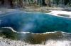](http://d32ogoqmya1dw8.cloudfront.net/images/microbelife/Octopus01.jpg)

[Octopus Spring](http://serc.carleton.edu/microbelife/topics/octopusspring/index.html): Octopus Spring is a partially alkaline, low-carbonate, low-sulfur hot spring located in the Lower Geyser Basin of Yellowstone National Park. It is home to a variety of thermophiles, as well as a colorful array of microbial mat communities.