|  |  |  |  |  |  |
| --- | --- | --- | --- | --- | --- |
| **Nutrients** | **Chick (0–3**  **months)** | **Grower I (3–6**  **months** | **Grower II**  **(6–12 months)** | **Conditioner**  **(12–18 months)** | **Breeder**  **(>18**  **months)** |
| C.P. (%) | 20.86 | 20.9 | 19.28 | 19.1 | 20.03 |
| M.E(kcal/kg) | 2225 | 2205 | 2191 | 2103 | 2428 |
| Calcium% | 0.53 | 0.63 | 0.67 | 0.7 | 3.45 |

**Ostrich**

**Broiler Guinea fowl feed requirements**

|  |  |  |  |  |  |
| --- | --- | --- | --- | --- | --- |
| Feed item | Age in weeks( different phases) | | | | |
|  | Starter(0-4) | Grower (4-8) Grower 8-12 | | Finisher 14-16 |  |
| Protein % | 24 | 20 | 18 | 16 |
| Metabolisable energy Kcal/kg | 3200 | 3100 | 3100 | 3100 |
| Amount of feed per day(g) | 25 – 30 | 50-60 | 70-80 | 70-80 |
| Calcium % | 1.2 | 1.00 | o.8 | 0.8 |

**Breeder feed Requirements**

|  |  |  |  |  |
| --- | --- | --- | --- | --- |
| Feed Item | Age in weeks | | | |
|  | Starter (0-4) | Grower (4-8) | Grower 8-12 | Breeder >16 |
| Protein% | 22 | 18 | 14 | 18 |
| ME kcal/kg | 3000 | 2800 | 2800 | 2800 |
| Amount of Feed Per day (g) | 25 – 27 | 55-60 | 70-80 | 70-90 |
| Calcium% | 0.70 | 0.60 | 2.70 | 3.0 |

**Turkey**

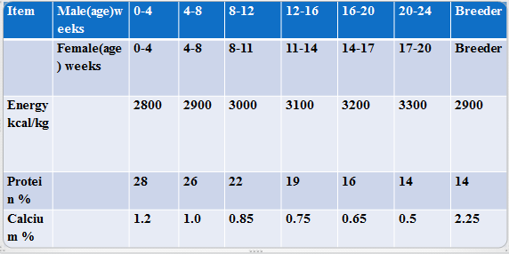

**partridge**