Social Organization in Mammals
Social organization in mammals refers to the way individuals within a species interact, form groups, and establish social structures. Mammalian social systems are shaped by ecological factors, reproductive strategies, kin selection, and evolutionary pressures. These structures influence resource access, mating success, survival, and communication.
Types of Social Organization in Mammals
1. Solitary Living
- Some mammals live and hunt alone, coming together only for mating.
- Examples: Tigers, Leopards, Bears.
- Solitary species often defend territories to ensure access to food and mates.
2. Pairs (Monogamous Systems)
- A male and female form a long-term pair bond, often raising offspring together.
- Examples: Wolves, Beavers, Gibbons.
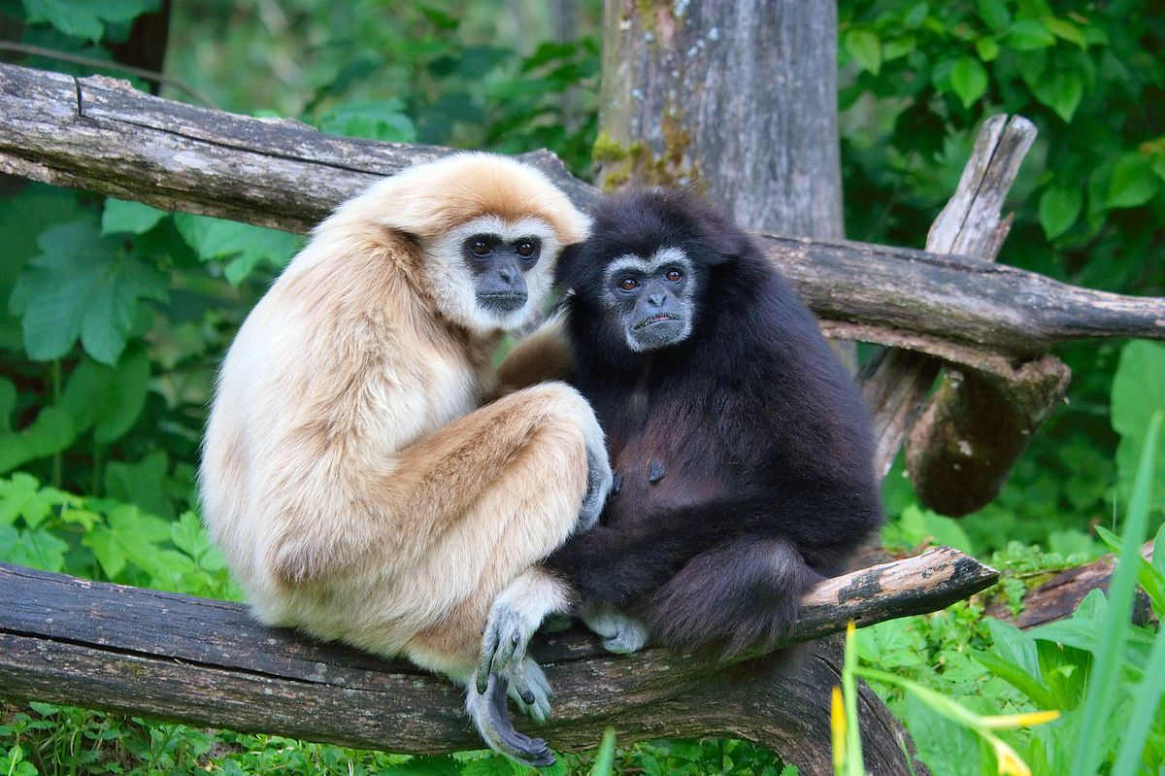
- Monogamy is common in species where parental investment is necessary for offspring survival.
3. Harem (Polygynous Groups)
- A single dominant male mates with multiple females, while other males remain subordinate.
- Examples: Lions, Gorillas, Seals.
- These groups ensure genetic diversity and resource defense.
4. Multi-Male, Multi-Female Groups
- Several males and females coexist in a large social group with complex dominance hierarchies.
- Examples: Baboons, Elephants, Dolphins.
- Such systems promote cooperative defense, resource sharing, and social learning.
5. Fission-Fusion Societies
- Groups frequently split and reunite depending on resource availability.
- Examples: Chimpanzees, Dolphins.
- These societies allow flexibility in dealing with changing environments.
6. Polyandrous Groups
- A polyandrous mating system in mammals is a reproductive strategy where a single female mates with multiple males within a single breeding season.
- This system is relatively rare in mammals compared to polygyny (one male, multiple females) but does exist in certain species.
- Examples: African Wild Dogs, Bats and Marmosets
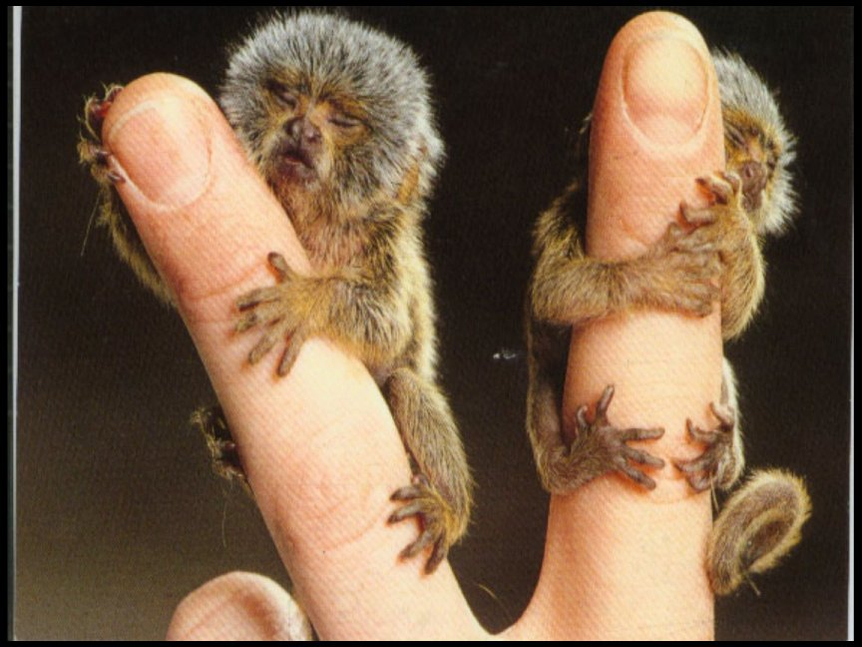
Factors Influencing Mammalian Social Organization
- Ecological Conditions – Food availability, predation risk, and habitat type shape social structures.
- Reproductive Strategies – Mating systems and parental care influence group formation.
- Kin Selection & Altruism – Cooperation among relatives enhances survival and gene propagation.
- Communication & Learning – Social animals develop complex communication and cultural transmission.
Benefits of Social Living
✔️ Enhanced Protection from Predators
✔️ Cooperative Hunting and Food Sharing
✔️ Increased Reproductive Success
✔️ Better Care for Offspring
✔️ Knowledge Transfer Across Generations
Challenges of Social Living
❌ Competition for Resources & Mates
❌ Spread of Diseases & Parasites
❌ Social Conflicts & Hierarchy Struggles
Conclusion
Social organization in mammals is diverse, ranging from solitary to complex eusocial systems. These structures are influenced by evolutionary, ecological, and behavioral factors, allowing mammals to adapt and survive in different environments.

